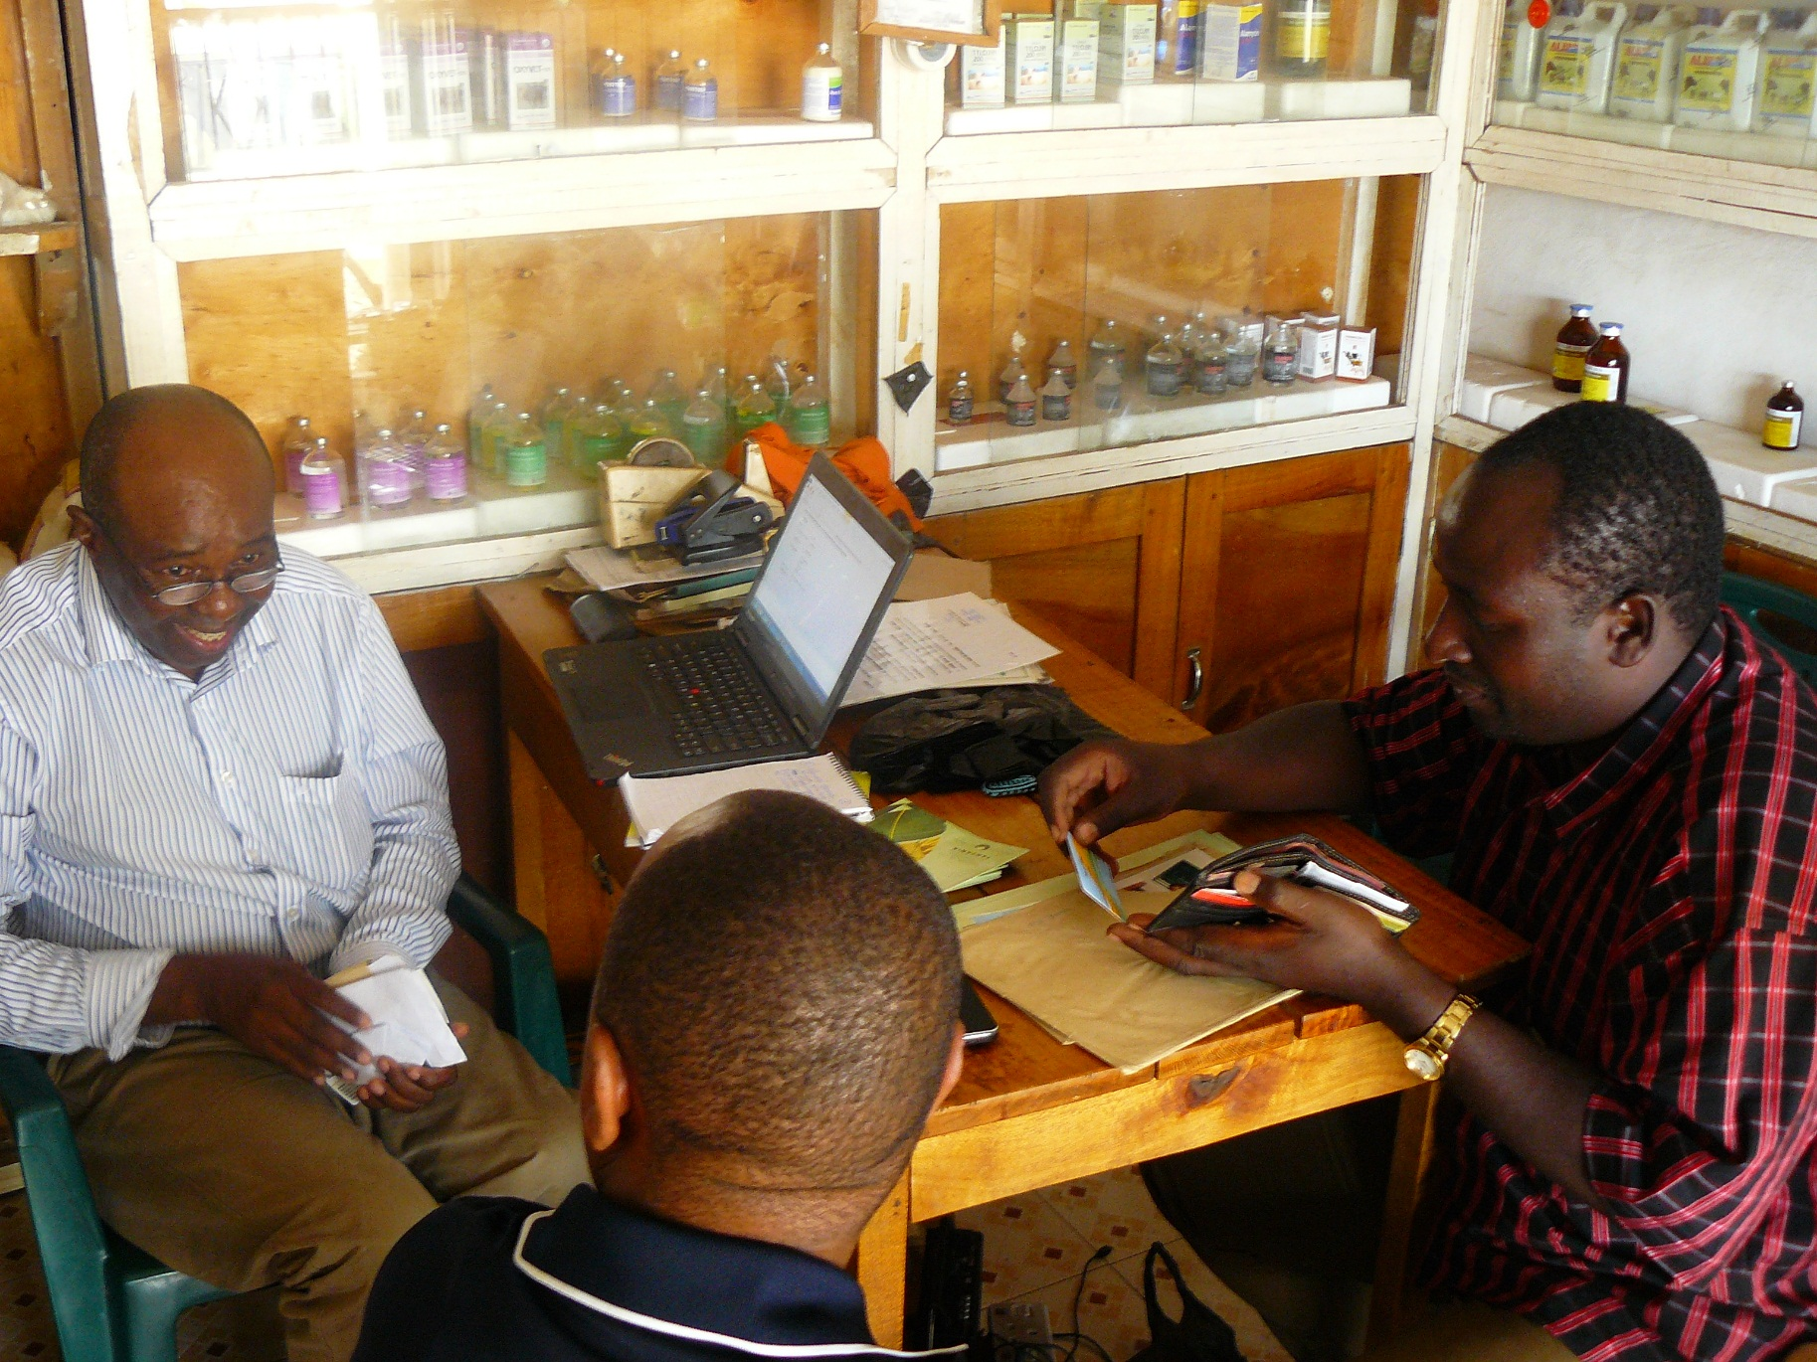
Information Needs Assessment Tanzania

Royal Tropical Institute (KIT), Amsterdam
Wouter Kleijn, Helena Posthumus

July 2015
Commissioned by CABI

Executive summary
This study provides an information needs assessment for Tanzania. A quick scan on the usefulness of a selection of ASHC and Plantwise materials was conducted as part of the assignment as well. Together with a separate study and fieldwork conducted in Ethiopia, it should provide input for the development of a measurement and evaluation module for Phase II of the ASHC program. It also aims to give entry-points and insights for further formulation of the program in the years to come, both in content and format of information materials as well as the distribution of them.
For farmers the most important sources of information (in order of importance) are family and neighbours, the yearly Nane Nane agricultural fair, product labels, public extension, research institutes, private extension (mostly by agro-input companies).

For Agro-dealers, demos and training by agro-input companies as well as a nationwide agrodealer support programs are sources of information. For agro-input companies colleagues are important as well as the company itself supplying (through training and literature) new information on new products to their staff.

Public extension workers have colleagues, farmers, research institutes and to a lesser extent manuals and training at their disposal.

Information material production and dissemination is an intricate process that takes several steps. Determining the right content and format is key, and this can take quite some time. But even the ‘perfect information material’, will not reach farmers or intermediaries without the right dissemination strategy.
In terms of content, important conclusions arose from discussions with farmers. In and around Arusha and Mbeya more information was needed on crops such as maize, beans, potatoes and vegetables. Only the first two are priority crops for the BMGF. In some areas other crops were deemed to be relevant as well, which can be addressed through co-sponsoring with other partners working on multiple crops or CABI, outside of the scope of ASHC grant.
Information to farmers should be specific; both crop specific as well as providing detailed information on which products to use, how to apply, at what dosage, where to buy these, etc. Information for farmers should be concise with texts reduced to the minimum. It should also be comprehensive, containing information on the whole production cycle (including land preparation and post-harvest management practices). Finding the right balance might be a challenge however, hence prototype testing could be useful to test different content arrangements (as well as formats).
Information on new inputs (seed varieties, fertilizer and pesticides) and pests/diseases was considered to be crucial as new products and pests come and go. Some information needs of farmers are not directly related to ISFM or pest management, such as post-harvest practices and market information. Information should be agro-ecological zone specific. Interviewees recommended to distinguish the three main agro-ecological zones (lowlands, medium, highlands) for any materials that promote improved seed varieties or cropping practices. Finally, contact details should be included at all times to encourage interaction.
For intermediaries information needs are often similar to those of farmers. Information on diseases and new inputs (pesticides, seeds, fertilizers) were frequently mentioned. The same goes for ‘non-ISFM related information’ such as market information and information on processing.
Agrodealers specifically said they would need information on improved inputs on time. They need to receive information (or visit demoplots) prior to the agricultural season in order to effectively sell the new products to the farmers. There is also a demand to better equip agrodealers with more comprehensive information on the entire process of crop production. Public extension workers pointed out that general guides and manuals are often too generic. Hence information should be crop specific.
In terms of formats, TV might be difficult due to irregular access by farmers and even extension workers Most farmers interviewed did not use radio as an important source yet radio has the potential to reach a larger audience and a partnership with experiences organizations like Farm Radio International could be useful. Piloting film screening could be worthwhile to test, as many interviewees (both farmers and intermediaries) preferred film after training and demos to educate farmers and intermediaries, especially in areas where the literacy level is low.
As for written materials, manuals can be useful for intermediaries. Manuals are inappropriate for small-scale farmers as they want concise texts and strong graphics. Farmers gave very different answers about their preferred format. Piloting different print formats (calendars, leaflets, posters) together with non-written materials, targeting the same type of end users for the same crop, while measured in terms of value for money, is advised.

Besides this other observations were that text should be limited, more photos should be used, text should not be too small as farmers often have difficulty reading, paragraphs should have a clear subject line at the beginning of each paragraph, photos should be depicting real life situations and local farmers as much as possible and finally, written material should be of durable quality paper.
The dissemination of materials should go hand in hand with training on the promoted practices and technologies. Almost all interviewees stressed the importance of practical training and demo-plots to engage with farmers a) to promoted ISFM practices and technologies and b) for information materials to be effective. As the capacity to provide training by individual organizations and companies is limited, this implies a pluralistic approach, engaging with both public and private sector and NGOs.
For the private sector, agrodealers are an entry-point. Agrodealers can be trained to give more appropriate information to farmers This can be combined with the provision of information material at agrodealer-level (e.g. manuals) as well as agrodealers providing more comprehensive materials to farmers. A distinction should be made between agrodealers and the actual vendors in the shop. The actual vendors should be targeted as they interact with farmers directly.
Agro-input companies organize demos and training for farmers, often together with partners. These training can be an entry-point to disseminate material. Some of the companies interviewed, expressed clear interest in more comprehensive materials on particular crops relevant for their products. Agro-input companies have already set up their own strategies and networks for dissemination and training of new practices. Through partnerships, bilateral and multilateral, these networks could be utilized for dissemination of information materials.
Training by public extension workers could be used to provide information materials. As a target-group of information materials themselves (manuals for example) extension workers are an interesting group as they lack proper supply of up-to-date information. In addition, partnerships with research institutes and NGOs should be considered for dissemination.
Some important, overarching issues to consider for dissemination are also the quantity of materials, reliance on lead-farmers and targeting women.

Acknowledgements
This study was commissioned by The Centre for Biosciences and Agriculture International (CABI), funded by the Bill and Melinda Gates Foundation. We thank all who participated in the study; a full list of interviewees can be found in the Annex.
In particular we want to express gratitude to the ASHC team for their guidance throughout the process, facilitation and critical feedback. Also local consultants Getahun Mitiku, Abere Mnalku (Ethiopia) and Peter Shao (Tanzania) were extremely pivotal with regard to local facilitation and sharing of their experience and knowledge.

Royal Tropical Institute
Mauritskade 63
1092 AD Amsterdam
The Netherlands
http://www.kit.nl/sed
Disclaimer: The views presented in this paper are those of the authors and do not necessarily represent the views of KIT or our partners.

Contents

Executive summary 1
Acknowledgements 3
1. Introduction 5
1.1 Rationale 5
1.2 Methodology 5
2. Information sources and needs at grassroots level 7
2.1 Current Information sourcing farmers and intermediaries 7
2.1.1 Information sources used by farmers 7
2.2 Recommendations for (improved) information materials and dissemination 12
2.2.1 Content 12
2.2.2 Format 15
2.2.3 Dissemination 17
Annex 1: Review of selected material in Tanzania 23
Annex 2: Practical insights from fieldwork for prototype testing 26
Annex 3: Itinerary 28
Annex 4: Questionnaires 30

Introduction

1.1 Rationale
The African Soil Health Consortium (ASHC) led by CAB International and funded by the Bill & Melinda Gates Foundation (BMGF), is a project contributing towards the understanding and use of ISFM techniques in sub-Saharan Africa. So far, ASHC has played the role of a content broker, generating an ISFM handbook and cropping system guides for use by extension workers to promote adoption of ISFM-based soil fertility management practices.
In phase 1, ASHC and its partners generated about 130 information materials on various crops in various formats ranging from print, audio-visual, text and radio programs. The material is available in seven different languages (with some films in 22 languages). As well as materials on ISFM, ASHC was also contracted to prepare materials for the five main pests (including diseases/weeds) for 12 target crops of the BMGF.

The main aim of phase 1 was to develop content and make it available for use by partners to increase ISFM awareness of identified audiences – with a particular focus on smallholder farmers and the intermediaries that provide them with information. However, many of the organisations that used the services of ASHC, did not have the resources to reproduce and use materials in dissemination activities. In a parallel work strand ASHC paid for innovation pilots to support information dissemination in different media including youth media (radio, social media and comics), secondary level school curriculum support materials, SMS and television.

Phase 1 ended in June 2015. Phase 2 will continue support to add value in developing materials. The activities will concentrate on working on a series of specific targeted ISFM campaigns designed to meet the information needs of smallholder farming families. Phase 2 will see scale-up campaigns in up to 5 countries (Nigeria, Ghana, Tanzania, Kenya and Uganda) between 2015 and 2019. These campaigns will be designed to encourage collaborative working across a wide range of partners to support approaches that overcome failures in the information supply chain from research and development of new approaches and techniques to smallholder farming family members looking for information. Phase 2 activities include the testing of information prototypes, piloting delivery mechanisms, and implementing scale-up campaigns to promote uptake of ISFM practices.
Information needs assessments were not needed in phase 1 because ASHC responded to the stated needs of ISFM promoters. The move to a campaign approach suggested a need for a deeper understanding of information needs to inform development of campaign activities. KIT was therefore commissioned to carry out a rapid information needs assessment in Ethiopia and Tanzania to provide insights for designing new materials as well as delivery channels in ASHC2.
This report contains the findings of the information needs assessment carried out in Tanzania.
In addition, a rapid assessment was carried out on the usefulness of a selection of ASHC and Plantwise materials (which can be found in the Annex, together with some inputs for the development of prototype testing tools). Together with the findings from Ethiopia, this study will provide input for the further development of ASHC activities.

1.2 Methodology

The ToR formulated the following two objectives:

- Carry out an information needs assessment – focusing on expected intermediaries and intermediary-end-user interactions to be involved in scale-up campaigns envisaged by ASHC.

- Obtain insights into the usefulness to different users of the information primarily of ASHC self-published materials on ISFM (ASHC handbook, four or five cropping guides) and ASHC and Plantwise materials on pests.

The primary focus of this report is on the first objective, that is, the information needs assessment in Tanzania. The fieldwork was conducted over the course of two weeks in the Mbeya and Arusha regions of Tanzania. Semi-structured interviews were conducted with a range of stakeholders such as agrodealers, representatives of public research institutes, public extension workers and their superiors, agro-input companies and farmers. An overview of the complete list of interviewees can be found in Annex 3.
The research team wanted to make sure ample attention was paid to the perspective of the actors that use information materials themselves. Hence the emphasis of the study is on grassroots-level intermediaries that are in close contact with farmers, such as agrodealers, agro-input companies and public extension field staff. In other words, professionals that provide information directly to farmers. This means that staff in agro-input shops working behind the counter were interviewed rather than the shop owners or managers as well as extension agents instead of their supervisors.
A limitation of the study was the geographical scope. As field work was concentrated in the Arusha and Mbeya regions, the conclusions and their overall generalizability are compromised. Another limitation has been the few publications that were translated into Swahili and applicable to the agro-ecological zones visited in Tanzania. Originally CABI provided a list of materials, yet most of the materials were in English or other languages, not Swahili. A selection was a made of materials that were translated to Swahili and applicable to the agro-ecological zones we visited. Unfortunately, this selection resulted in only a few materials. More details can be found in Annex 1.
Separate reports are available regarding the information needs assessment in Ethiopia and the rapid assessments (objective 2) of the published materials on ISFM (produced by ASHC) and pest management (produced by Plantwise). Quite some findings in Tanzania were found to be similar to the findings in Ethiopia, although significant differences exist, for example with regard to the envisioned dissemination strategy. Some of the findings from Ethiopia, when relevant, are also referred to in this report through the use of text boxes. For more details we refer to the other reports.

2. Information sources and needs at grassroots level
2.1 Current Information sourcing farmers and intermediaries
This chapter discusses what sources farmers and grassroots-level intermediaries in Tanzania use to access information on agriculture. The main information sources are summarized in the table below (Table 1).
Table 1. Main sources used for agricultural information by grassroots-level actors
Category of respondents |  | Information sources (in order of importance)
 | Farmers | Family and neighbours, Nane Nane agricultural fair, product labels, public extension, research institutes, private extension (demos and training by agro-input companies)
Intermediaries | Agrodealers | Demos and training by agro-input companies, nationwide agrodealer program
 | Public extension workers | Colleagues, farmers, research institutes, manuals (rare), training (rare)
 | Agro-input companies | Colleagues, from superiors (the company training and literature)
 | NGOs | Mostly from their own programmes and ‘experts’, research institutes (rare)

2.1.1 Information sources used by farmers

The most common sources of information for farmers are family members and neighbours. This information is mostly provided in a very informal manner, through a combination of sharing experiences as well as observations of practices and input/technology use.
Interestingly, a majority of the farmers said that they draw information and inspiration from the annual Nane Nane agricultural fair. This one-week fair takes place around the eighth day of the eighth month (August) in eight locations across Tanzania. A national fair is held in a different town each year and simultaneously accompanied by events organized in seven zones; in Morogoro (Eastern zone), Tabora (Western zone), Mbeya (Southern Highlands), Mwanza (Lake Zone), Arusha (Northern Zone), Lindi, Mtwara or Songea (Southern zone) and Dodoma (Central zone). Farmers and other stakeholders such as researchers (from universities and research institutes), agrodealers and input companies come together and display new technologies and exchange knowledge.
Farmers mentioned product labels of agro-inputs quite frequently as a source of information. However they also noted that information provided by labels is limited and often generic, without being adapted to the specific agro-ecological context of farmers. Labels give information on the dosage (usually a standardized recommendation) and recommended practices on how to apply it. As such there is no information on other stages of the crop production (weeding, land preparation, early harvesting etc.).
Farmers mentioned the private sector as a source of information, notably agrodealers. However, most farmers interviewed said agrodealers themselves give only very limited advice, if at all. Their information provision seems to derive from the information on the product labels (recommended dosage and application). For example adequate information on the appropriate amount of fertilizer (adjusted to the local agro-ecological zone) and how to do topdressing properly, was often not mentioned by either agro-dealers and product labels.

Some farmers mentioned public extension workers as sources of information. In Tanzania, the current public extension is relatively weak. Estimations of the number of public extension workers vary widely, ranging from one extension worker serving 469 up to 2,307 households, with a national average ratio of 1:630. These estimates combined both crop and livestock officers, while only the first category is relevant for ASHC promotion campaigns. Out of the 10,891 officers employed in 2012, 6,925 are crop specialists. There is an ongoing effort by the Tanzanian Government to increase the number of extension workers. As the government aims to have at least one extension worker per village, the number is expected to rise to 15,802 this year.

The national agricultural policy does not prescribe a specific approach towards extension. However, in practice, extension workers often work through established farmer groups (sometimes called economic groups). Groups can be formed as a part of a development project, government intervention or by farmers themselves. Groups usually consist of 10-20 members and have a small demonstration plot on which they jointly cultivate crops. This is where the extension workers conduct trials and occasionally organize field days. Group members running these demo-plots are supposed to disseminate the information further onwards in the community, yet there are neither strong incentives nor control mechanisms in place to enforce such dissemination. Some of the group representatives interviewed said they also receive support through research institutions.
There is some evidence for increasing support by the government for farmer-to-farmer learning models, which originally stem from a program for the dissemination of the SARO5 rice variety. No data is available on the actual level of support, the scale of this approach, let alone its results beyond the SARO5 rice variety program. In the areas where the interviews were conducted extension workers did not explicitly make use of a farmer-to-farmer approach.

Farmers are sometimes organized around irrigation schemes or village-based loan schemes as well. The various irrigation schemes in the country have been built with support of the Government. The schemes receive special attention and support in their activities. For example, members of the Uyole irrigation scheme cooperative visit other irrigation schemes across the country, or other cooperatives visit Uyole, to exchange knowledge. The Mbeya city council finances these knowledge exchange trips.
Village loan schemes and village community banks are informal village-based savings and credit groups. These groups differ in size, formality and turnover. One farmer interviewed said he was part of a group with 14 members, meeting up every month. Members contribute TSH 20,000 (close to 10 USD) every month. Two members will receive TSH 200,000 (close to USD 100) every few months, to be used for investments. Other groups, often supported by NGOs throughout the years, have formal ties with financial institutions and can provide credit as well. In 2009, village community banks were up and running in 19 out of 25 regions in Tanzania with 56,280 members in total.
Estimations of the numbers of farmers organized in groups vary highly between areas, yet it is safe to say that the majority of farmers are not members of any group. For example, in Kisongo, Arusha region, each village (with at least 300 households) has on average one group of organized farmers. Definitions of organized groups vary, but members were said to meet formally at least once a week during the cropping season. Farmers discuss topics related to agriculture, ranging from technical issues to marketing. Sometimes these meetings are used by extension workers to provide training. Some of the farmer groups share a plot of land which is used for joint cultivation.
One extension worker in Tukuyu described how he would randomly visit farmers, besides his engagement with the groups, to make sure attention is evenly divided as much as possible. However it is clear that the majority of farmers have little regular interaction with the local extension workers as they mainly engage with established groups rather than individual farmers. Women are usually under-represented in groups, and seldom occupy a leadership position hence extension provision is biased in favour of the men.
In areas in the proximity of research institutes (like Selian Agricultural Research Institute or Uyole) farmers at times mentioned these institutes as a source of information. For example, one farmer was used as a lead farmer and received advice on a structural basis by phone. Other farmers interviewed were engaged in previous programmes and training provided by research institutes. However, the initiative is often taken by the research institute, rather than the farmers. This means that the research institutes determine the information that is made available and select the farmers that receive the information. It is rare that farmers themselves approach research institutes to request information.

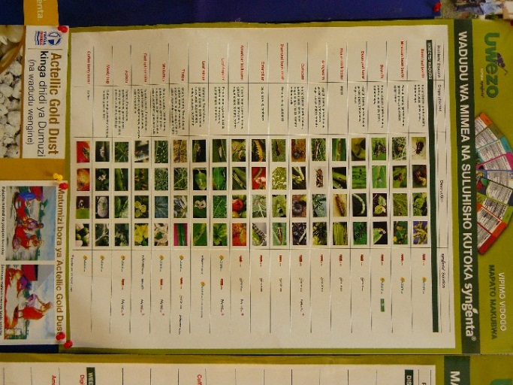
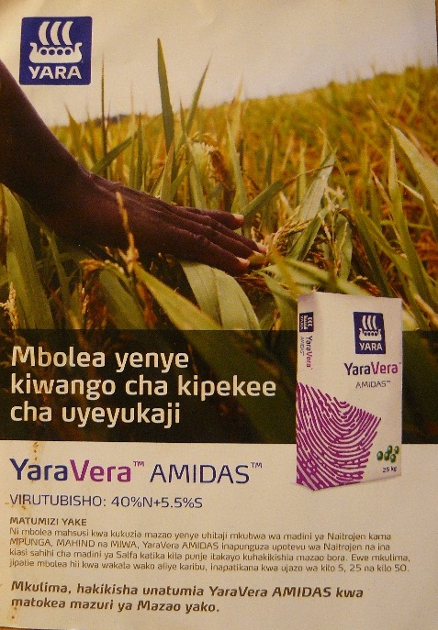
Another source of information for small-scale farmers are the demonstrations of new products on demo-plots organized and financed by input companies in order to market their products. The demonstrations usually involve information provision on improved agro-inputs and training on how to use them effectively. The training and inputs are provided by the company staff. Depending on the company and the area, multiple training sessions are organized throughout the season, starting from planting to harvest. This training often takes place on the demonstration plot or in a communal building in the nearby village. Farmers and other attendees often receive promotion material regarding the promoted inputs during the demos (see below for examples). However these demonstrations are localized, and usually the attendees are agrodealers and public extension workers who will bring along a few of the more advanced farmers in their networks (lead farmers). Most farmers that were interviewed for this study did not attend such demonstrations.
Figure 1. A poster by Syngenta, depicting several pests and diseases and the products offered by Syngenta that can help to alleviate the problem. The poster was pinned to a wall of the agricultural district office of the Tukuyu district. (left photograph)
Figure 2. A commercial flyer of YaraVera Amidas. The content is promotional and does not provide information on usage, let alone more general agricultural best practices. (right photograph)

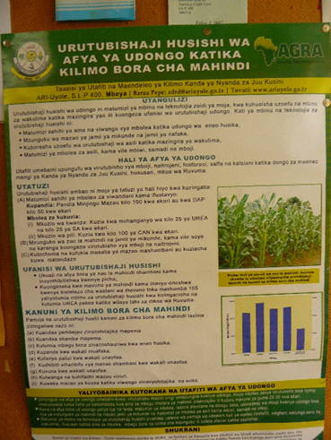
Other than demo plots arranged by agro-input companies and the limited advice given by agrodealers, private extension is mostly limited to closed value chains for export commodities, such as tea, coffee and tobacco (not included in B&MGF ‘focus crops’). NGOs provide extension services as well, usually targeted at specific areas or villages.
In general written materials (leaflets and posters) are very rare at the farmer level. The exception to this is some of the commercial promotion materials for inputs available through agrodealers. Yet these materials, like the labels, usually provide limited information only. Besides the dosage recommendation and recommended practice on how to apply it, there is no information on other stages of the crop production such as weeding, land preparation, early harvesting etc., which are all pivotal for the efficient use of the inputs as well. Moreover, the materials have a particular emphasis on one or more products of the company marketing the product(s).
Figure 3: A poster produced by the Uyole research institute. This was the result of a research trajectory, funded by AGRA, to conduct soil nutrient research.

Occasionally posters are produced by research institutes, promoting new varieties or certain practices. These posters can be found at agro-dealer shops, district agricultural offices and at local village headquarters (see Figures 1 and 2).
Written information materials are often limited in terms of their quantity. For example, three lead-farmers of economic groups (one from Siha, two from Karatu) said in a group interview that “it is difficult to get the pamphlets” which are sometimes distributed in their area by the NGO RECODA. On some occasions they would receive more than the number of group members and share these materials with other community members who are not part of the economic group.
Farmers in the Arusha area received information from the Selian Agriculture Research Institution (SARI) on maize intercropping with cowpeas, pigeon peas and lablab. CABI provided information materials on indigenous vegetable varieties (African eggplant, nightshade, spider plant). But according to the extension agent interviewed in Kikwe, Arusha region, “they came only once, it was not a continuous process”. Also the number of information materials provided was not sufficient. About twenty folders were distributed in total for two producer groups, which was about half of what was needed if one is to provide each farmer with a folder.

Some farmers also mentioned radio and TV as sources they rely on for information. Yet the information they receive and use was very limited. Firstly, as is the case in Ethiopia, most radio and TV items related to agriculture were broadcasted at irregular times. Secondly, most radio and TV coverage of agriculture was said to be ‘newsy’ i.e. stories that stand out and are not presenting ‘common practices’ and therefore disconnected from reality. Thirdly, the news often relates to a situation in a different agro-ecological context, hence not very applicable to the listener or viewer in question. The TV programs on national and regional stations are general programs with multiple items - instead of a program on a weekly basis fully dedicated to agriculture. From time to time a program, quite randomly, features a story on agriculture. Perhaps the most limiting factor is that most farmers have access to TV only sporadically.
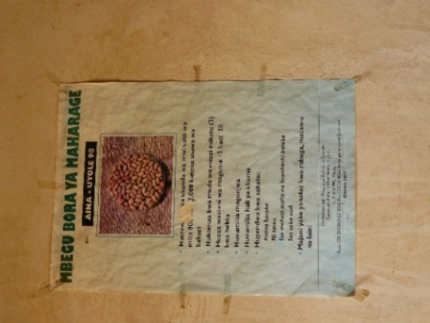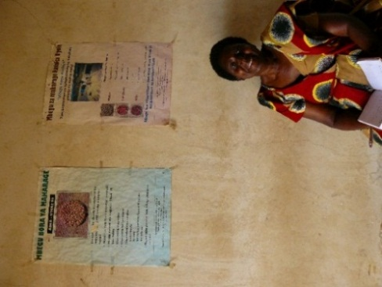
Figure 4. New varieties by the Uyole Research Institute promoted through posters at a local village headquarters.
2.1.2 Information sources used by intermediaries
Intermediaries were divided into three categories: agrodealers, agro-input companies and public extension workers.
In Tanzania there has been a push since 2008 to build an agrodealer network. The total number is estimated to be around 4000, although not all are fully operational. Some of the agrodealers were severely hit when the subsidized voucher scheme was abandoned last year, although some interviewees thought that the voucher system might return in the coming season.

Agrodealers, mostly supported through agro-input companies, facilitate demonstrations of new inputs and in addition provide information in their shops. The main source of information of agrodealers themselves are the demonstration plots facilitated and financed by the agro-input companies. Companies were said to reimburse traveling costs and provide refreshments for participants during organized field days. The purpose of the plots is to show a combination of agrodealers, public extension workers and lead farmers the merits of the inputs promoted by the respective input company. Some agrodealers have received training throughout the years as part of the National Agricultural Input Voucher Scheme program. However it should be noted that the ‘trainees’ are usually the owners of the shop instead of the vendors dealing with the farmers.
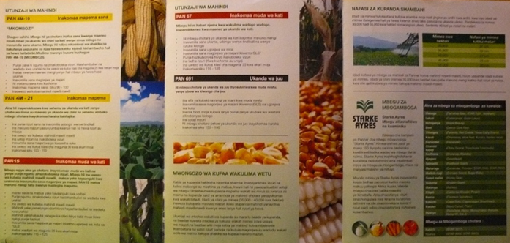
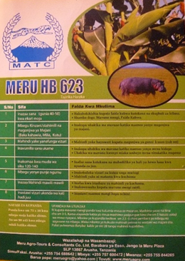
Several agrodealers reported that new products are quite regularly released without a clear indication of why they are introduced and how they should be used. Often it is also not clear to the agrodealers, or the farmers, why the old product has been taken out of stock. For example, Miagie Sakaya Kivuto, agrodealer and owner of Mihasaki Agrovet in Kisongo (Arusha), said this happened in the case of the Pannar maize seed variety (PAN 4M-21) which was taken out of stock without explanation. Brochures are being provided to agrodealers to disperse to farmers, yet they have not seen the variety tested on a demonstration plot while having to convince farmers of its improved quality.
Figure 5. A folder by Pannar provided to farmers through agrodealers. The folders gives a short introduction to each of their varieties available for purchase.

Figure 6. A promotional leaflet by Meru promoting its maize variety Meru HB 623, symbolized by a hippopotamus. The leaflet gives some detailed information on usage of the seed.
Information sources for staff of agro-input companies are mostly from the companies themselves that provide information and (occasionally) training on new products launched. They also learn from the demo-plots which they set up or at least coordinate to promote their new products.
Extension workers source most of their information from farmers and colleagues, and the Nane Nane show. Extension workers especially learn from farmers on the pros and cons of new inputs and about new diseases and pests affecting their crops.

In the areas where this study was conducted, extension workers mentioned the nearby research institute quite frequently as source of information on improved practices and inputs. Some extension workers said they occasionally receive a manual or training, from either a research institute, the Ministry of Agriculture or an NGO. For example Efransia Mushi, ward extension officer of Tukuyuhas attended some training workshops recently. The first training was organized by the Ministry of Agriculture on the topic of business skills, another training was sponsored by FAO and dealt with best practices of vegetable farming. After the training she received information materials to continue learning. Yet such training and workshops tend to be ad hoc and irregular rather than a consistent source of information. TV and Radio are only occasionally used as a source, as is the case for farmers, and for the same reasons. Internet was only mentioned by one younger extension workers who used it to research new weeds that pose a challenge to farmers.

2.2 Recommendations for (improved) information materials and dissemination
This section provides suggestions and recommendations where information materials could be improved. Determining the right content and format is key, and this can take quite some time. However, even though the information material may be appropriate and relevant, it will not reach farmers without the right dissemination strategy. For example, one cannot assume that a leaflet on maize production with useful information and pictures will result in adoption by small-scale farmers at scale unless it is distributed in some way!
2.2.1 Content
While discussing information needs, various suggestions related to relevant content of information materials for agriculture were made during the discussions with farmers and intermediaries in Tanzania.

Farmers:

- The crops most frequently mentioned by interviewees for which more information was needed included maize and beans, potatoes, and vegetables. Yet the information needs differ slightly per area. For example in Babati and Sahi, according to the extension workers representing those areas, information on sunflower, sesame and yellow soybeans would also be very useful.

- Information to farmers should be specific. Firstly, information should be crop specific. Secondly, materials on diseases and pests should provide detailed information on which products to use, how to apply, at what dosage, where to buy these, etc.

- Information should be comprehensive yet concise. Texts for farmers should be reduced to the minimum. We came across many information materials that had too much text, but too little visual information. Interviewees stressed that the information should be comprehensive in that it encompasses all stages of the crop production process from land preparation to post-harvest management. This is especially relevant for commercial leaflets that often do not provide any practical information. And when they do, it is limited to very basic information on dosage and application practices. In practice, however, it might be a challenge to include information about the entire crop cycle (including land preparation and post-harvest management practices).

- Information on new seed varieties, fertilizer and pesticides was considered to be important also. Input provision is constantly changing as new products are launched on the markets, yet information is lagging behind. For seed varieties, this means information on proper spacing and weeding practices for example, but also information on what other inputs (e.g. fertilizers, pesticides) to use. For fertilizers and pesticides, clear instructions on which products to use, the dosage for application, and timing of application is necessary and how this relates to other agronomic practices.

- Crop diseases such as the maize lethal necrosis disease and the ‘tuta absoluta’ are disastrous for farmers. Again, information on these diseases should be practical. Farmers (but also intermediaries) want to have more detailed on the symptoms of these diseases and pests, which product to use, and at what dosage and time. Information on the dosage of pesticides is often put in hectares, but should be converted to local measures.

- Some information needs of farmers are not directly related to ISFM or pest management, but may still be worthwhile to consider to be addressed. Post-harvest practices and market information were very often mentioned, by both farmers and intermediaries. The quality of harvested produce is compromised due to suboptimal post-harvest practices, resulting in lower prices and/or nutritional value of the crop. Many farmers and intermediaries also complained about the lack of reliable market information (where to sell which crop at what time). They complained that often middlemen take advantage of this knowledge gap. Although it should be noted that is some cases such concerns can reflect a lack of understanding of the value added by middlemen in cleaning and sorting grain that is not well prepared and in the transaction costs of collecting, transporting and marketing the product.
Textbox 1. Lack of feedback mechanisms
Most materials lack a feedback mechanism to stimulate interactivity between the content brokers and the users. An exception is the possibility to call in and send text messages to Farm Radio International-supported radio-programs. This was mentioned by Farm Radio but could not be verified as the farmers interviewed for this study only listened to radio occasionally.
In most cases the materials currently reaching farmers only have a logo and name of the organization responsible for the production of the material. A positive exception is the flip chart on maize in Swahili and the one-page leaflet ‘Healthy Maize, better harvest, phosphorus’ leaflet edited by SARI. An e-mail and contact address are provided as well as a telephone number, which farmers and intermediaries can call for more information. This information was appreciated by some of the farmers interviewed, while reviewing some of the selected ASHC materials.
Equally, no (or few) feedback mechanisms are being used to test the impact of material (again with the exception of FRI). No structural means are in place to evaluate the effectiveness of the content, format and dissemination strategy of information products.
- Sometimes difficult words in Swahili are used instead of more commonly accepted words in Swahili or English. This can be confusing for farmers. Hence appropriate translation to common language is necessary. For example the word “viatilifu”, a new word for pesticides, fungicides and insecticides, was used quite regularly in some materials, yet incomprehensible for farmers.

- Information should be agro-ecological zone specific. Various interviewees recommended distinguishing the three main agro-ecological zones (lowlands, medium, highlands) for any materials that promote improved seed varieties or cropping practices. For example, in Mbeya the lowlands include Mbozi, Kyela, Mbarali. The medium zone includes Mbeya, part of Mbozi and East Rungwe. The highlands include Kilembo, Rungwe, Tukuyu, part of Mbeya and part of Santilia.

- Information materials rarely have feedback mechanisms in place. Hence contact details (address but also a phone number through which more information can be gathered) should be included at all times to encourage interaction.

Farmers requested fertilizer recommendations to be provided for each agro-ecological zone separately. However, opinions differ to what extent such recommendations can be standardized. According to Minjingu, a producer of compound fertilizers, generic fertilizer recommendations are sufficient to start with. But some farmers commented that the recommendations should be more adapted to the local context. For example, three farmers (two from Karatu, one from Siha) argued in a group discussion that the blanket recommendations on the ‘SARI Maize Production flipchart’ were not appropriate. The suggested dosage on the chart is one cap of a bottle. Yet soils in the Kilimanjaro area are ‘over farmed’, according to the farmers. Thus dosages need to be increased and therefore two or three caps should be advised, according to the interviewees.

A balance should be struck between clarity and specificity. The process sketched out in the section on dissemination (2.2.3) leaves room for testing the material on its suitability to the local agro-ecological context. Just as important however are the economic incentives for farmers to use inputs. Recommending fertilizers for a farmer with half a hectare of food crops might not be very sensitive to his/her reality of capital constraints and therefore ability or need to purchase improved inputs. In such a case, with land and capital constraints, low-cost improved practices could be promoted such as weed management, mulching, compost and intercropping.

Intermediaries:
- Some of the information needs of intermediaries are the same as for farmers. Information on diseases and new inputs (pesticides, seeds, fertilizers) were frequently mentioned. The same goes for ‘non-ISFM related information’ such as market information and information on processing. For example, one extension worker said she would like to have more information on potato processing as she works with farmer groups that want to process potatoes into crisps.

- Agrodealers specifically said they would need information on improved inputs on time. Currently they only see the effects of improved inputs on demo-plots during the season when they are having the products in stock already. Agrodealers want to receive information (or see demo-plots) prior to the agricultural season in order to effectively sell the new products to the farmers.

- There is a need to better equip agrodealers with more comprehensive information on the entire process of crop production. Hence crop manuals will be useful. However the impact of such information materials are likely to be much higher when accompanied by training and demonstration plots. If such an approach would take place, for example by joining with AFAP to train agrodealers, it is essential that the participants are shop vendors not shop owners, unless the latter are actively involved in selling the products directly to farmers and advise them as well. More importantly, it is inappropriate to consider agrodealers as ‘backup extension workers’, as agrodealers are too pre-occupied with their business activities.

- Public extension workers pointed out that general guides and manuals are often too generic. Hence information should be crop specific. An example of information material being too generic is a guide on vegetable production produced by the Ministry of Agriculture, financed by FAO. Two versions were produced. One guide was meant for extension workers but extension staff interviewed considered it consisted of too much text (see Figure 7). A more concise and more basic version, with many more graphics was developed targeting farmers and extension workers (see Figure 8). However, both manuals were very generic, dealing with vegetable cultivation in general and giving no crop specific information and recommendations for different vegetable crops and varieties
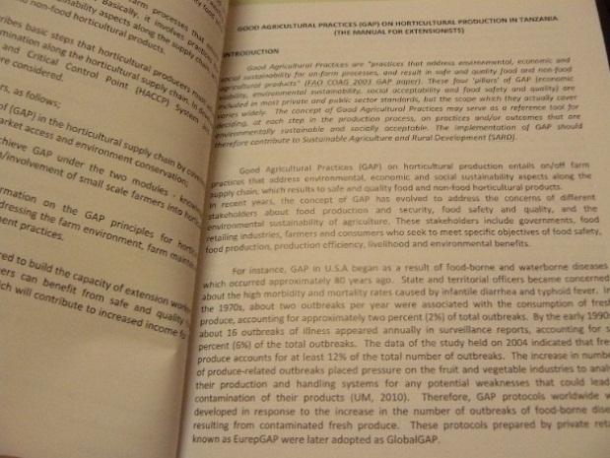
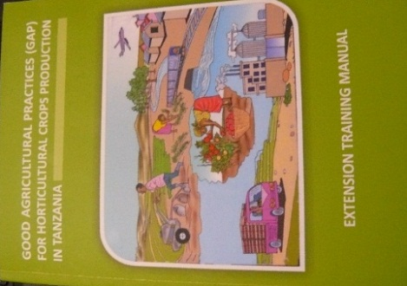
Figure 7. A guide for extension workers on GAP for horticultural crops production in Tanzania

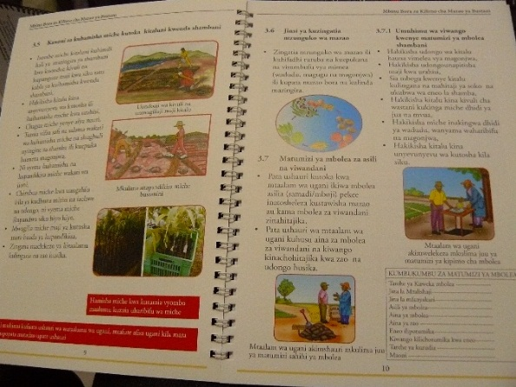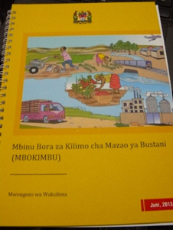
Figure 8. A more concise guide for extension workers on GAP for horticultural crops production in Tanzania

2.2.2 Format
Audiovisual

Audiovisuals were mentioned as a potentially strong means to convey information related to ISFM and pest management. However, most farmers and even extension workers interviewed have irregular access, if at all, to TV and television programs. Although most farmers interviewed did not seem to use radio as an important source of information, radio has the potential to reach a larger audience and experiences of Farm Radio International provided evidence where use of radio had led to positive change (see Textbox 2).

It would be interesting to pilot the use of film material through projectors, as many interviewees (both farmers and intermediaries) preferred films/documentaries after training and demos to educate farmers and intermediaries, especially in areas where the illiteracy level is high (for example in the Masai-dominated areas). Digital Green does not have a presence on the ground in Tanzania as of yet but has been partnering with Farm Radio International (FRI) to develop some films/documentaries. Possibly this could be an entry-point for partnerships in Tanzania as well. Syngenta also uses film to share information. Syngenta staff visit communities and bring tents and video screens to teach and train farmers as they see extension and information to farmers as central to their approach. Partnering with Syngenta would be a way to get films out to the field.
Another possibility would be to use SMS, which can be useful for very basic information on planting time, dosage recommendations, IPM etc. SMS is already being used in various countries as a useful tool for sharing market and price information. None of the farmers interviewed however said they used SMS based services.
Textbox 2. Radio broadcasts in Tanzania
According to the statistics radio is still one of the most effective ways of communication, simply because of the very high usage rate. Around 80% of sub-Saharan African households have access to radio, compared to 60% for mobiles. As such, radio is one of the important ways of communicating ISFM-related information to end users. Also in Tanzania the coverage of radio is “fairly wide”. For example, it is estimated that a radio channel like Abood FM can reach over two million people in total radio coverage, with half of the listeners from rural areas. Access to radio was not cited as a very important source by the farmers interviewed However, the sample was small and unlikely to be representative to the entire farmer population.
Radio to disseminate information is often understood as buying air time and disseminating a relatively concise message. In practice this approach is expensive and has limited impact, according to Farm Radio International (FRI). Hence the approach pursued by FRI is quite different. Key to their approach is to piggyback on the relationship between the talk show host/radio DJ and the audience. They convince programme managers/broadcasters to pay more attention to agriculture at a set time weekly (8-9 in the evening for example, when farmers are not in the fields) as it also benefits the radio station since a lot of their listeners are farmers.
In Tanzania there are 100s of radio stations. FRI currently works with 8-9 of these and have experience on a multitude of crops, like cassava, oranges, sweet potato, rice, sesame, vegetables and sorghum as well as some other issues such as mental health.
A senior program officer at FRI, sees little value in written materials by themselves and noted: “If you want to keep it secret in Africa, write it down”. However, she also noted that manuals for extension workers and dissemination of materials to farmers in combination with training on the same crop/technology that is being discussed through a radio campaign, could be beneficial. This is similar to the opinions of most other interviewees who claimed that printed materials with no other interaction is not useful.
An example given was the success of the teff row planting campaign in Ethiopia that, according to sources, was the result of combining different approaches lead by the Ministry of Agriculture including radio, distribution of a printed folder describing the practices and training to farmers and extension workers and; training for both groups. The combination of approaches had positive results.
The program did have some interesting results:
- More than 2.4 million adult Ethiopians heard the participatory radio campaign programs on improving teff planting practices in four regions (Tigray, Oromiya, Amhara, SSNPR).
- More than 750,000 households adopted at least one improved teff planting practice in the four project regions, far exceeding the Staples project goal of at least 180,000 households.
- The BMGF-funded project was extremely cost-effective, spending only USD 0.38 per farmer to reach farmers who tried improved teff planting practices, and USD 0.03 per farmer to deliver an hour of agricultural information to Ethiopian listeners (measured in farmers reached).
- The radio broadcasts reached a huge audience, more than 2.4 million. Approximately four of five adults living in communities in range of the radio signal knew about the programs and listened to at least one of the broadcasts.
- More than three-quarters (77%) of listeners planted teff in rows. Listeners were 2½ times more likely than non-listeners to plant teff directly to their field in rows.
- The more frequently respondents listened, the more likely they were to plant teff directly to the field in rows.
(Source: Evaluation Study Teff Row Planting Campaign, FRI).

Written materials
Manuals can be useful for intermediaries but are not appropriate or cost-effective for small-scale farmers as they want concise texts and strong graphics, to create very practical information.

When asking farmers about their preference of format, their answers varied widely. Some prefer leaflets as they can carry it to the field, some argue that posters are more useful as they can pin them on the wall at home and look at it daily and some find calendars the most practical as it provides them with visual information on when to conduct sowing, weeding, harvesting etc. A possibility would be to pilot different print formats targeting the same type of end users for the same crop. Other, non-print formats, could be included as well. Effectiveness should be measured in terms of value for money.

Other observations with regard to the format of information include:
- In general, written materials often feature too much text and too little pictures/photos.
- Text should not be too small as farmers often have difficulty reading. Moreover paragraphs should have a clear subject line at the beginning of each paragraph.
- Photos should be depicting real life situations as much as possible and depicting farmers in the area (from the tribe of the targeted farmers if possible)
- Written material should be of durable quality paper. If not, materials might be used “to make fire and to wrap food”, as one respondent observed. Although inevitably there is likely to be a trade-off between quality and cost, especially given earlier points about the limited numbers of materials available.

2.2.3 Dissemination
This section provides entry-points for dissemination of information materials in Tanzania. Dissemination occurs through partners, hence a brief introduction to possible partnership arrangements is also discussed.
From the analysis in section 2.1 it follows that farmers receive information from a variety of actors: the public sector (extension and research), the private sector (agrodealers and agro-input companies), NGOs and other farmers (farmer groups and farmer-to-farmer). A pluralistic strategy for dissemination seems most fitting for Tanzania as there is not one main actor that provides a source of information to, or is engaged with, farmers. This implies a strategy in which agrodealers, input companies, public and private extension all have a role to play.
Almost all interviewees deliberately stressed the importance of practical training and demo-plots to engage with farmers to promote improved practices and technologies related to ISFM. The dissemination of materials should thus go hand in hand with training on the promoted practices and technologies because a) training and demo-plots are still judged to be the most effective way to influence farmers and b) disseminating information just by itself (‘standalone’) was deemed to have little impact. The choice of partners and partnerships should take this into account as well. The limited capacity to provide training by individual organizations and companies is another reason for a pluralistic approach, collaborating with multiple partners.
The table below summarizes the type of actors that could be partnered with for dissemination, potential entry-points to do so and potential (dis)advantages of cooperation. This is discussed in more detail in the remaining paragraphs.

Table 2
Actors | Potential entry-points for dissemination | Advantages (+) and Disadvantages (-)
Agrodealers  Approximately 900 functioning in Tanzania | Vendors could be trained to give more appropriate information to farmers, combined with the provision of information materials for agrodealers themselves (e.g. manuals) and providing materials for farmers that can be displayed or given away. | + Close to the farmer  - Agrodealers are more business-minded, hence knowledge on agricultural practices is limited and they have little time available. Vendors are usually not knowledgeable
Agro-input companies  Yara, Meru Seed, East West Seed International, Afrisem, Highland Seeds, Syngenta, Bayer, Seedco, Pannar, Zamseed, etc | Organize demos and training for agrodealers, extension workers and some (lead-)farmers, often together with partners. These trainings can be an entry-point to disseminate material. Expressed interest in more comprehensive materials on crops relevant for their business  Improved pack design and pack inserts could be used by suppliers | + Already have a relatively well-established network of partners which can be utilized  - Promoting their own product is key
Public Extension  On district and ward-level | Provide training through farmer groups and other farmers in community. This training and linkages could be used to disseminate information materials.  Can be target-group of information materials (manuals for example), accompanied by training if possible. | + Know the area and have established linkages with farmer groups  - Overburdened, little motivation and resources
Research Institutes  Agricultural Research Institute Maruku, ARI Ukuriguru, ARI Uyole, SARI, ARI Mikocheni, ARI Makutupola, ARI Naliendele, Tropical Pests Research Institute | For the promotion of certain improved inputs, technologies or practices cooperation with the research institutes could be considered. Personnel can assist in both training (or training of extension workers from other public and private sector) and development of the materials. | + Qualified personnel  - Often top-down  - Research staff are few in number, extension is not their main mandate
NGOs  Farm Radio International , FIPS-Africa, RECODA, WorldVision, etc | Linkages with farmer groups/communities and provide training. These could be used to disseminate information materials. Information materials can be developed jointly as well. | + personnel can be quite qualified and resourceful  - restricted by donor and deliverables  - target specific communities (especially local NGOs)

Agrodealers
An estimated 900 agrodealers are currently operational in Tanzania. Agrodealers can be trained to give more appropriate information to farmers (together with partners such as AFAP). This can be combined with the provision of information material at agrodealer level (e.g. manuals) as well as agrodealers providing more comprehensive materials to farmers. An advantage is that the agrodealers are cIose to the farmers, which includes the farmers that are not part of organized groups, potentially providing more inclusiveness.
A disadvantage is that agrodealers sometimes have little knowledge on agricultural practices. Hence, they cannot be considered as agricultural advisors for farmers and they have little time available to provide in-depth training to farmers. In the words of the coordinator of the Tanzanian Soil Health Consortium: “Most agrodealers are business boys”.
Another issue linked to this, and pointed out by a representative of Yara, was that there is a clear difference between the vendor in the particular shop and the actual owner of the shop(s). Often the shop vendors are the ones who are supposed to give advice, yet the meetings or field days are usually attended by the shop owners. This implies two things: 1) Materials need to be adjusted so that they are useful (in terms of education and comprehension level) for vendors; 2) Training should be targeted at vendors instead of business owners. In practice this might be difficult to enforce as the business owners are likely to volunteer themselves to attend the demos as they will need to decide whether to sell the inputs or not.

Agro-input companies
Agro-input companies organize demos and training for farmers, often together with partners. This training can be an entry-point to disseminate material. Some of the companies we interviewed, expressed clear interest in more comprehensive materials on particular crops relevant for their products. For example representatives of Yara and Seedco said they would appreciate the ASHC cropping guides very much, if adjusted to the local context.
Agro-input companies have already set up their own strategies and networks for dissemination and training of new inputs. For example, Meru Seed Company (breeder and producer of maize seed) said they engage with 300 groups in order to promote their varieties through demo plots and training. Some of these groups were set up by the company, but many were already established by NGOs such as FIPS and World Vision, or by other input companies. Textbox 3 provides some insights into the network of agro-input companies.

Three forms of collaboration can be distinguished:
1) Bilateral partnerships
Private sector partners are mainly interested in promoting their own product. However the Notore Urea deep placement in Nigeria films shows ASHC is open to this as long as it is line with ISFM principles. The film raised quite some interest among field managers of companies like Syngenta and Yara.
2) Multilateral partnerships I
Interviews with some of the company representatives revealed a willingness to work together, not only with development partners, but also with other private companies. However, promoting materials that will not have any specific reference to their product (so for example information materials that do not promote a certain Seedco variety) might prove to be a challenge. It might mean ASHC produces principles and ‘basic’ products sponsored by different companies. The same film or other materials contain different product info as it is developed. In order not to confuse farmers, partners would probably have to target different areas and farmer groups.
3) Multilateral partnerships II
Another possibility however are collaborative efforts to promote different categories of products (seeds, pesticides and fertilizers), as is the case in the Last Mile Alliance (see Textbox 3).
Company representatives revealed an interest for material that goes beyond the proper use of inputs as they are very much aware of the importance of all other aspects of crop production as well. In fact, Yara helped to develop a farmer business school under the umbrella of Competitive African Rice Initiative and has developed a crop manual on rice together with other input companies. They showed interest in developing more manuals, for example on, maize, beans ,tea, coffee potato, sunflower and tomato. Only maize and beans are key crops for the BMGF, yet for other crops co-sponsoring could be an option.
Other companies interviewed, like Meru, Highland Seeds, Seedco and Syngenta, see the value of investing in farmers as well in order to push their products. A company like Syngenta for example has invested in a farmer training centre, where farmers are welcome to visit and ask questions at no costs. They also visit communities and bring tents and video screens to teach farmers in a very proactive manner. They see extension and information to farmers as central to their approach. In the Arusha area agro-input companies such as East West Seed International as well as Afrisem and Sevia could be potential partners, if promotion of improved vegetable varieties such as onion, tomato, watermelon, papayas are also considered relevant.
Public extension
Public extension workers provide training through farmer groups and at times (quite randomly and informal) to other farmers in their area as well. This training could be used to disseminate information materials. As a target audience of information materials themselves (manuals for example) extension workers are an interesting group as they lack proper supply of up-to-date information.
An advantage of using extension workers is that they often know the area well and have established linkages with farmer groups, yet are usually overburdened and consequently little motivation or resources, to participate in activities.
Research Institutes
Cooperation with the research institutes can be considered for the promotion of certain improved inputs, technologies or practices. Personnel can assist in both training of trainers on the content of ASHC material and development of the materials (manuals for example). Research institutes could also be assisted in improving their own information provision and information materials as the quality of current information material could be greatly improved. An advantage of collaboration is that research institutes have qualified personnel, yet the research and the technologies can be disseminated in quite a top-down manner without taking account of the realities of the farmer., It should also be noted that there are even fewer research staff than extension staff and their mandate is for research not extension. Therefore roles need to be carefully defined.
NGOs
Cooperation with NGOs depends on the area in which they are active and the kind of program implemented. Some of the NGOs have a reasonable capacity to provide extension services and training (see Textbox 3 for examples of some organizations). Some NGOs have strong linkages with farmer groups and communities. The training they provide could be used to disseminate information materials. At times NGOs disseminate information materials themselves. These efforts could be supported. An advantage of working with an NGO is the personnel, which is relatively well qualified and has resources for training (unlike public extension personnel for example). On the other hand, it is often constrained as it has its own agenda and deliverables set by the donor, which are leading for the program. Local NGOs usually work in very targeted areas. This would limit impact at scale by any individual NGO suggesting that interventions would need to mobilise networks of local NGOs.
Textbox 3. Dissemination network of agro-input companies
Agro-input companies use a pluralistic network of partners to pilot and market their products. An interview with the Regional Sales agronomist for Yara (Mbeya region), provided some insight in the established network of one of the bigger agro-input companies and the biggest fertilizer company active in the country. This network of partners is utilized to provide extension services and demonstration plots at farmer level. An overview of the partners involved is useful as it gives an idea of the pluralistic network that could be established for training and distributing information materials or perhaps even accessed through a partnership with one or several of these companies.
Civil Society partners (numbers in brackets are nos. of field extension officers active)
Hanns R. Neumann Stiftung Africa – coffee (15 extension officers)
Technoserve – maize. The project revolves around a warehouse recipient system yet with a training component as well (around 6)
RECODA – Agrodealer development program (?)
Farm Input Promotion Services – Africa (4)
Rural –Urban Development Initiatives (?)
Tanzania Horticultural Association (?)
Yara also participates in the Competitive African Rice Initiative (CARI) and in NAFAKA. NAFAKA Staples Value Chain Activity is a $30 million project funded by USAID under the Tanzania Feed the Future (FTF) Initiative and partners with processing companies (which employ another 3 extension workers).
Private partners (numbers in brackets are nos. of field extension officers active)
Seedco – maize seeds (2)
Kibo seed – vegetable seeds mostly (3)
Meru Agro – Mostly maize, some sunflower and sesame (3-4)
Highland seeds – Mostly maize, some sorghum , sesame and sunflower as well (3)
Brac - microfinance company (4)
Tembo coffee - (4 and lead farmers)
Coffee Management Services - (3)
Tanzania Coffee Research Institute - (2)
Agriseed – (?)
Rafa group in Uyole - (3)
Balimi microfinance – tea (?)
WATCO – tea (?)
Several companies in tobacco in the Thunia distict. In total 29 extension officers.
Yara also collaborates with Syngenta (5 extension workers in Mbeya), Bayer International (1) and Seedco (4) as part of the Last Mile Alliance. In this alliance they support agrodealers in setting up demoplots through training and providing the necessary inputs. Yara is focused on balanced crop nutrition, the other companies on seed or crop protection. Whenever there is a training they partner with Seedco and either Syngenta or Bayer.
Together this amounts to 50 extension workers at least (excluding the extension workers active in tobacco as this is a closed value chain), without taking into account the public extension workers and the network of lead-farmers.

Other important points to consider for dissemination are:
- Quantity of materials
Often there are few materials available. For example in the case of the CABI material on indigenous vegetables, only 20 information materials were distributed to two producer groups only. This implies a strategic choice as well. Do you produce materials for all farmers in a certain area or group, or do you limit those expenses by targeting lead-farmers or a selection of farmers, relying more on farmer-to-farmer dissemination and learning. The latter option has its drawbacks (see below) but saves costs which could be used to reach more areas and groups instead. In the prototype testing phase this should be explored further.
- Reliance on lead farmers and farmer groups has its drawbacks
Often, materials are provided to lead farmers only (given the limited number of materials available), assuming that they will pass on the information to others. This is often a fallacy as there are not many incentives for a lead farmer to do so. She/he might not have a good relationship with the other farmers, or is too pre-occupied etc. In fact, a shortage of material could even increase the gap between the lead farmer and ‘normal’ farmers. Furthermore, the numbers of lead farmers and the groups they represent are very limited. The vast majority of farmers in Tanzania are not organized in groups.
- Targeting women
It is widely known that female farmers are often neglected by information providers; this is also true in Tanzania. Extension services for example do not efficiently reach out to female farmers. As the economic groups are usually the entry point for public and private extension to engage with and train farmers, access to information for women is restricted. Also the composition of the groups leads to bias as women are usually under-represented in groups, and leadership positions in groups are dominated by men. This holds implications for any effort to supply information. Women can possibly be reached more effectively by making sure that training accompanying the information materials are specifically targeting women or by working with women groups.

Another entry-point would be to think of producing materials or using delivery channels specifically tailored to women. For example by putting more emphasis on topics such as nutrition, harvesting and sowing. Another way is to subtlety use a gender-sensitive narrative through information materials. An example of this is the comic “Malkia saves the seeds”. In the story Malkia (a girl) plays the leading character and the one who ‘saves the seeds’ as she comes up with the idea of ISFM. Her grandmother also plays a prominent role and is on equal footing with the male characters. Towards the end the storyline is supported by a real-life case study (provided by FIPS Africa) in which a female farmer is interviewed on the use of best practices of ISFM.

Annex 1: Review of selected material in Tanzania
This Annex provides an overview of two ASHC information materials translated into Swahili reviewed by farmers and extension workers in Tanzania. Opinions are paraphrased. Originally CABI provided a list of materials, yet most of the materials were in English or other languages but Swahili. Hence a selection was a made of materials that were translated to Swahili and applicable to the agro-ecological zones we visited. Unfortunately, this selection resulted in only a few materials.
Selected materials include:
1) “Ongeza Mavuno Na Kipato” / The SARI Maize-pigeon pea poster in Swahili (printed in A4)
2) “Uzalishaji Bora Wa” / The SARI Maize Production flipchart (printed in A4)

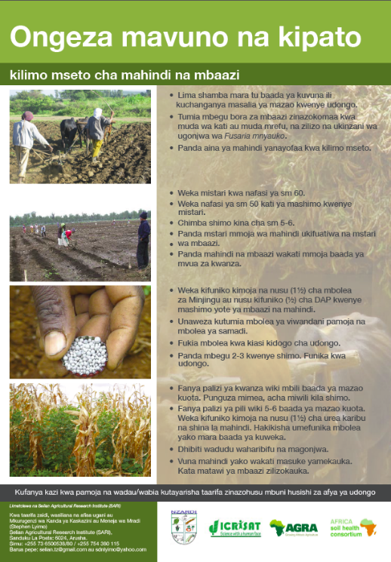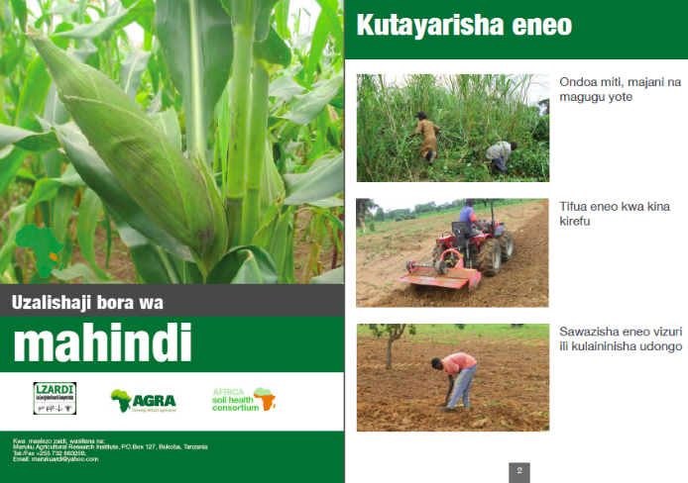
“Ongeza Mavuno Na Kipato” / The SARI Maize-pigeon pea poster in Swahili (printed in A4)
Interview agrodealer and owner of Mihasaki Agrovet (Kisongo, Arusha) 5/5/2015
Interviewee believes this material is much better than the Pannar flyers because the latter are not specific and visual enough, especially with regard to spacing.
Something new he learned from the folder was that normally for topdressing he and other farmers put the fertilizers around the seed but without covering them, as a result the fertilizers wash away.

This folder advises to cover the fertilizer with soil.

The contact information on the folder was also appreciated
Interview with three farmers (Kingori) 06/05/2015
In the area farmers do zero-grazing, according to the interviewee. As such they take crop residues for feeding their cattle. Yet from the poster she learns to plough it back in to the soil.
Interview with two female seed producers (Maiwen village, Kikwe) 07/05/2015
The interviewees thought the fonts too small, so it is very hard to read. The interviewees recommended that every paragraph should have a title to prevent confusion.
Interview with two female farmers (Kikwe) 07/05/2015

The fonts were considered too small, which makes it difficult to read. The pamphlet mentions to control pests but does not contain information on how to do so.
“Uzalishaji Bora Wa” / The SARI Maize Production flipchart (printed in A4)

Interview with three lead farmers (Arusha) 5/5/2015
According to interviewees the chart looks fine but blanket recommendations are not correct. One cap (of bottle) of DAP is advised, but the dosage should often be higher and differs per area. The farmers believed the recommended dosage should be doubled for most soils. They were of the opinion that in some areas where “lablab” is grown as intercrop or manure is used, one cap is enough. However they argued that soils in the area of Kilimanjaro are ‘over farmed’ and so dosages would need to be increased to two or three caps in absence of manure or leguminous crops such as lablab.

Interview with three farmers (Kingori) 06/05/2015

Male farmer:
- The chart is missing some aspects of the crop production and harvest cycle, according to the interviewee. It should be noted that these aspects are featured but the use of photos first, then a drawing and then photos again is confusing for the farmers. It gives them the idea that not the entire process from land preparation to harvesting is featured. Consistency is important.
- He notes that Minjingu doesn’t dissolve fast and therefore its effect is less immediate, especially with little rain. CAP is not used at all. Hence only the recommendations for DAP and to some extent Minjingu, are relevant.
- He likes the information on covering fertilizers with soil. According to him many people in the community still do not use this practice as they are often people from highland areas working on rented land with little exposure to improved practices, training and knowledge exchange with locals.
Female farmer:
- The interviewee has learned from the pictures that she has to plough deep (which is recommended by the material). She has started doing this as of this year and it has increased the performance of her production. In that sense the information provided by the material is in fact s a confirmation of what she is doing.
Interview with two female seed producers (Maiwen village, Kikwe) 07/05/2015
One of the producers learned something about the spacing. Before he was not sure about the correct spacing but the flipchart gives clear recommendations on this. Both materials were thought to have too little information on pesticides.

Information on maize and beans for intercropping can be together in one poster but for vegetables they would like to have separate materials (i.e. crop-specific).

Interview with two female farmers (Kikwe) 07/05/2015
One of the farmers commented that she learned about the right dosage, she normally uses only 0.5 or 1 cap. But the recommended dosage is 1.5 or 2 (Note that this is a farmer that has been trained quite frequently and leads a group).
- She also learns from the flipchart that you have to do intercropping at the same time. Common practice, also for her, is to plant pigeonpea only after the maize has started to grow.
- Both women missed information on pest, diseases and control (including dosages)
- One woman said that she wants to have something smaller because that way she can put it in her bag and carry it around.

Interview with four farmers (Tukuyu) 12/5/2015

The farmers agreed that the information on pesticides was too complicated, often difficult terms (‘new Swahili’) were used. The farmers appreciated the logical flow. A pamphlet form was preferred as they could bring it to the field. Spacing (row to row, seed to seed) was new to them and very useful. They would like to have more information on prices and new inputs.

Interview with agronomist for the Last Mile Alliance

- Interviewee comments that the recommended dosage in the area for Minjingu mazao is only 1 or 1.5 cap in the area.
- Thiodan dust is not available in the area, only Khalid.
- In terms of format he’d like posters instead of brochures; overall he appreciates the flip sheet very much.

Annex 2: Practical insights from fieldwork for prototype testing

- Time is of the essence. Usually you will have a maximum of one hour at best with participants, after which the concentration span and energy goes down and participants lose interest. Hence, if local translation is needed, you will have probably 30 minutes to ask your questions. With that in mind, prototype testing should be brief. Depending on the amount of users you are going visit, it is possible to rotate some of the questions (see 5.5).
- It is of the utmost importance to test the material with the right audience. In terms of importance the actual act of asking questions is only half of prototype testing. The other 50% is preparation and planning and making sure the right target audience will be interviewed. This can be done in the following way:
a) Clearly define beforehand which material is going to be tested and who is the target group. For example a manual that is clearly written for intermediaries, should be tested on the public, private and NGO extension-worker level. But also, depending on the time and resources available, the goal should be to have as much of a representative sample of respondents available as possible. This means variety in terms of: gender, agro-ecological zones (yet for the same crop, assuming that most of the materials are crop-specific), literacy level, level of socio-economic development, land size and age. Within such categories as much diversity as possible should be covered. So for example group discussions with female farmers should also show as much diversity as possible in terms of age, literacy, socio-economic class, etc.
b) Make sure through your facilitators / partner organizations that the right audience is selected to ensure the variety mentioned above. This is where it often goes awry. For example if you want to test the material with farmers, usually you end up speaking to lead farmers instead who live in peri-urban areas, if you do not specify your target group. Hence it is key to have clear communication with field staff in charge of facilitation on the set criteria for selection as well as reviewing beforehand the proposed target areas and (groups of ) participants to be interviewed.
- The preferred method is to have a focus group discussion as this will give you more data compared to interviewing one single individual in the same time span. A group of 3-4 users per facilitator (and translator if needed) is advised. More than 4 participants will make the 30/60 minutes limit difficult if all respondents are to be heard and only advised if the facilitator holds sufficient experience.
- It is advised to provide each of the individuals with a different set of ASHC information materials, if available. This is preferred as quite often one of the more eloquent, talkative participants (usually the one with the most influence and a male) will try to dominate the conversation, causing a bias to your findings and evaluation of the material.
For example in a group with four participants eight materials will be distributed in the following way:
Respondent 1 – Material A & B
Respondent 2 – Material C & D
Respondent 3 – Material E & F
Respondent 4 – Material G & H
The facilitator will appoint the respondents to provide feedback after they ‘taking in’ the information.
In the case of prototype testing of only one information material in a group, the facilitator will have to be disciplined in allowing respondents to speak for a limited amount of time and to make sure everyone gets a chance to speak up. It is preferred to allow the less vocal/eloquent/influential respondents to speak up first in order to prevent them from confirming what the more influential character of the group has said before.
- The leading questions for testing are the following (obviously words can be rephrased in order for the target group to grasp the full meaning of the questions):
- A. Can you tell us what you like about the content/actual information of the material? Please also explain why you like the information.
B. Is there anything new in the information you got from this material - something you did not know before? If so, what is it?
C. How do you intend to use this new information?
D. Can you tell us what you do not like about the content/actual information of the material? Please also explain why you do not like the information.
- A. Can you tell us what you like about the way the material looks? Please also explain why you like it
B. Can you tell us what you do not like about the way the material looks? Please also explain why you do not like it
- Can you tell us how the material could be improved? Please be as specific as possible.
- How likely is it you would use this information material in the near future if available? (1 being likely, 2 don’t know yet, 3 not likely)
- In the remaining time the following questions should be asked. In case time is limited one question could be selected and explored in more detail. Questions A, B and C then rotate per (group) interview.
a) What topics would you like to know more about, if possible?
b) Which medium do you prefer and why?
c) How could this information reach as many end users in the community as possible? (it is important that the respondent is as specific as possible to shed light on a possible dissemination strategy)
- Important is to probe as much as possible. So for example when the respondents already hint at improvements while answering question 1, it is still important to probe at question three for any other possible improvements.

Annex 3: Itinerary

 | Activity | Location
19/04 | Arrival | Addis Ababa
20/04 – 21/04 | Preparation Workshop and field work | Addis Ababa
22/04 – 23/04 | Workshop  Day 1: Review Rhizobium Inoculation Manual  Day 2: Dissemination strategy and discussion information materials  Interview Asfaw Hailemariam, Technical Manager BioTech | Addis Ababa
24/04 | 2 Development Agents, Wolmera district  2 model-farmers | Wolmera woreda, Oromia region
25/04 | 2 DAs in the Ejere District  1 SMS in the Ejere District  2 model-farmers | Ejere woreda, Oromia regiona
27/04 | Deputy agricultural district office, Wolmera district  Nega Adafrie, head agronomist of the Robi Berga Farmers’ Cooperative Union | Wolmera woreda, Oromia region
28/04 | 2 SMS Kersana Malima district  2 development agents, Kersana Malima district  2 farmers | Kersana Malima, Oromia region
29/04 | Chimdo Anchala, Digital Green  Freyhiwot Nadew and Ian Pringle, Farm Radio International | Addis Ababa
30/04 | Roza Negash, World Vision | Addis Ababa
01/05 | Travel to Arusha, Tanzania
03/05 | Meeting local consultant Mr Peter Shoa  Preparation field work | Arusha, Arusha region
04/05 | Stephen Lyimo, Coordinator TSHC  Karen Hampson, Senior Program Officer FRI  Anup Modha, CEO Minjingu Mines and Fertilizer Ltd. | Arusha, Arusha region
05/05 | Jonas Masau, extension worker (Babati) and Godfrey Mlay, extension worker and agrodealer (Siha)  Miagie Sakaya Kivuto, agrodealer and owner of Mihasaki Agrovet,  Kisongo, Arusha.  3 lead-farmers (2 from Karatu, 1 Siha)  Helen Bradburn, founder and Executive Coordinator of Women in Agriculture Development and Environment Conservation (WADEC Tanzania) | Arusha, Arusha region
06/05 | Group discussion with 3 farmers in Kigori | Kigori, Arusha region
07/05 | Bala Badodkal, shop manager ETG Arusha  2 female seed producers Maiwen village, Kikwe  Interview Extension worker Kikwe  Interview 2 female farmers, Kikwe  Interview agrodealers, Kikwe | Kikwe, Arusha region
08/05 | Interview and field visit East West Seed International Tanzania | Moshi, Arusha region
11/05 | John Mbele, Marketing Officer Meru Agro  Yohana Jospeh, area manager Mbeya for the Syngenta Information Centre,  Advera Kagitwa, City Agricultural Officer Mbeya | Mbeya, Mbeya region
12/05 | Elizabeth Isaac Mushi, Extesnion Officer Uyole  Mr John Soda Muavelenga, Chairman Uyole Irrigation scheme  Wirri Mafongo, CEO of Mafongo Agro-inputs, Tukuyu.  Efransia Mushi, Extension officer of the ward, Tukuyu  Chesco Chaula (28), Extension worker, Tukuyu  Interview 4 farmers, Tukuyu | Uyole, Mbeya region  Tukuyu, Rungwe, Mbeya region
13/05 | Kephas Samwel Sima, Regional Sales agronomist for Yara (Mbeya)  Bonifas Masika, agronomist for the Last Mile Alliance  Patrick j mamlima, medium/large scale farmer, Mbozi district | Mbeya, Mbeya region  Mbozi, Mbeya region
14/05 | Alinanine shimwela (Production manager) and Faustin Bura (CEO) Highland Seeds  Michael David Rikanga, SeedCo Zonal Representative  Zacharia Malley, Director of Research Uyole Research Institute | Mbeya, Mbeya region  Uyole, Mbeya region
15/05 | Return flight to Amsterdam
16/05 | Arrival

Annex 4: Questionnaires One-on-one interviews (first and second level intermediaries)
1. General Data
- Date | : ______________________________
- Location (place, district, region) | : ______________________________
- Organization name | : _____________________________________
- Type of organization | : 0 Public / government  0 Private  0 NGO / CSO  0 Other: _______________________________
- Name(s) and gender:  1.  2.  3. | Position of respondents in their organization:  1.  2.  3.

2. Mapping Information demand of intermediaries
For higher level intermediaries (who usually have access to enough information, and are not in direct communication), the questions can be rephrased so that they will reflect on the lack of information of their employees/organization. For lower level intermediaries, a dual approach can be used, focusing both on their perspective on the farmer-level and their own information needs and searching behavior.
1. In the table below, please:
a) List what kind of information you need to successfully carry out the activities related to Soil Fertility and Pest Management
Think of: chemical fertilizer recommendations, organic fertilizer recommendations, IPM practices, soil nutrient maps, research outcomes on agricultural practices, etc
Probe: – a specific amount of fertilizer for a particular crop? Information that explains how to use fertilizer? Information that explains how using other soil management practices would influence the amount of fertilizer used
b) List which source/information channels you are currently using to search for information. Please be as specific as possible
Think of: training by government agencies and/or other organizations, radio, internet, magazines, journals, databases (e.g. GIS data), manuals/guides, colleagues, farmers, etc.
Do not focus on training, etc in remaining questions if not related to information materials. This is important otherwise most of the discussion will revolve around training.
c) Score for each information channel the frequency of seeking new information (with 1= yearly 2=monthly 3=weekly 4=daily).
d) Please explain why you use the mentioned information channels/sources for each of the activities mentioned
Think of: easy accessible, reliable, low costs, detailed, quality, regularly updated…
e) Describe for each information channel/source how the information could improve to suit your needs?
Think of: different information channel, increased frequency, increased reliability, increased suitability, etc
- Info needed | - Channel /source | - frequency | - why | - improvements
2. What kind of information (both in terms of content and packaging) is currently missing in your opinion?
Often is (partially) answered through question 1e
3a. Imagine a farmer has a question related to soil fertility or pest management, but you have no ready answer, what do you do?
Note: this question is more appropriate for second level intermediaries
3b. If your field staff repeatedly comes back with technical questions they, and your organization, doesn’t know the answer to, what do you?
Note: this question is more appropriate for first level intermediaries
4. What about yourself? Do you lack the appropriate amount of information?
Note: this question is more appropriate for first level intermediaries as they will probably reflect on their perspective regarding end-users oquestion 1-3.
5. Please describe:
a) How materials can be improved
in terms of content, format and dissemination
(a checklist of criteria can be found below. Note: this is from the original questionnaire which was adapted in the field).
ACTIVITY 1:

Content |  | Packaging/Design |  | Dissemination
Criteria | Rating & Explanation | Criteria | Rating & Explanation | Criteria | Rating & Explanation
Level of detail  Is the content detailed enough to be relevant? | 1 – 2 – 3 – 4  Explanation: | Suitability to audience  Is it suitable for the target group? Is it for example suitable in terms of age, gender, literacy, culture? | 1 – 2 – 3 – 4  Explanation: | Costs  Are the costs of reproducing the information and dispersing it feasible? | 1 – 2 – 3 – 4  Explanation:
Adapted to local context  Are recommendations adjusted to the local agro-ecological circumstances? | 1 – 2 – 3 – 4  Explanation: | Attractiveness  Is it visually or orally engaging enough in order to catch the attention of the audience? | 1 – 2 – 3 – 4  Explanation: | Timely delivery  Is the information reaching the target audience in time? | 1 – 2 – 3 – 4  Explanation:
Accuracy/Reliability  Is the information accurate and reliable? | 1 – 2 – 3 – 4  Explanation: | Participatory  Does the information encourage participation by intermediaries as well as users? Does it enable feedback loops? | 1 – 2 – 3 – 4  Explanation: | Scale  Is the information appropriate and ready to be disseminated at a larger scale? | 1 – 2 – 3 – 4  Explanation:
Difficulty  Is the information too simple or difficult? | 1 – 2 – 3 – 4  Explanation:
ADDITIONAL CRITERIAS?
6. Do you have mechanisms in place that allow you to give feedback to the sources of your information, in order to improve the quality of the information’s content, packaging and/or dissemination?
If so, please explain how they work, how often you use them and how effective they have been.
7. Do you have some examples of materials you use. Can you show them and tell us why you like them or not? How could they be improved?
3. Mapping Information supply by intermediaries
1. In the table below, please describe:
- Who approaches you for information? And how often?
- What are the most common questions your clients/farmers are asking, related to soil fertility and pest management?
- How are these questions different for different kind of clients/farmers?
- How do you address these questions?
Mostly oral by teaching and by demonstrating practical (demos at FTC) no informational materials
- How do you know users are actually using the information, if so: how are they using it and can you give examples?
- Do you feel confident to provide information / advice?
Please rate (1 = not confident, 2=somewhat confident 3=confident 4=very confident)
Can you explain when you feel very confident providing information and when you don’t? What are examples of this?
- What are other sources where users could get information regarding the question asked? What are the most trusted sources and why?
- What kind of other information are users asking for besides the information that you provide?
a. Who | b. Common questions | c. Different | d. Address | e. Actual usage | f. Confidence | g. other sources | h. Other info requested by users

2. When disseminating information, how do you adapt it to make the information is as useful as possible for clients/farmers?
3. How do you take into account the diversity among farmers when providing information (big/small, male/ female, food/cash, young/old, literacy, organized or not) Yes / No If yes, how?
4. Do you have mechanisms in place that allow users to give feedback to you on the information’s content, its packaging and dissemination?
How often and how do they give you feedback?

5. What are the main challenges you face in providing information to users and how could these be tackled?
6. Based on your experience what have been the most succesful information material you have worked with (for farmers) and which one the worst. Please explain why (especially works for positive examples)

4. Usefulness of the information of ASHC/PW materials (first and second level intermediaries)
Thank you. In this part of the interview we would like to have a look at a selection of the materials being produced by ASHC and Plantwise and see how they can be improved.
1. Per information ‘material’ please:
a. Describe for who do you think this is most useful?
b. Describe for which activity could it be used?
c. Estimate how likely it is that you and/or your staff would use this material? (1 not likely, 2 somewhat likely, likely and 4 very likely)
d. Describe your suggestions for improvement of the material
e. Score against each criteria, explain your answer and suggestions for improvement (in the rows below)
Material 1:
Target group (filled out by enumerator):
a. Useful for who:
b. For which activity:
c. Likeliness of usage (1-4) & Explanation:
d. suggestions for improvements

Content |  | Packaging/Design |  | Dissemination
Criteria | Rating & Explanation | Criteria | Rating & Explanation | Criteria | Rating & Explanation
Level of detail  Is the content detailed enough to be relevant? | 1. too little detail  2. about right  3. too much (irrelevant) detail  Explain your answer: | Suitability to audience  Is it suitable for the target group? Is it for example suitable in terms of age, gender, literacy, culture? | 1. Suitable  2. Somewhat Suitable  3. Not suitable at all  Explain your answer: | Costs  Are the costs of reproducing the information and dispersing it feasible? | 1. Costs are feasible  2. Somewhat feasible  3. Not feasible at all  Explain your answer:
Adapted to local context  Are recommendations adjusted to the local agro-ecological circumstances? | 1. too specific for local context (not transferable to other context  2. about right  3. too generic  Explain your answer: | Attractiveness  Is it visually or orally engaging enough in order to catch the attention of the audience? | 1. Very appealing  2. Some appeal  3. No appeal at all  Explain your answer: | Timely delivery  Is the information reaching the target audience in time? | 1. Information is on time  2. Not always on time  3. Too late  Explain your answer:
Accuracy/Reliability  Is the information accurate and reliable? | 1. accurate & reliable  2. inaccurate & unreliable  3. don’t know  Explain your answer: | Participatory  Does the information encourage participation by intermediaries as well as users? Does it enable feedback loops? | 1. Very participatory  2. Somewhat participatory  3. Not participatory  Explain your answer | Scale  Is the information appropriate and ready to be disseminated at a larger scale? | 1. Easily scalable  2. Somewhat scalable  3. Not scalable  Explain your answer:
Difficulty  Is the level of difficulty adjusted to the target group? | 1. too difficult  2. about right  3. too simple  Explain your answer:
ADDITIONAL CRITERIAS?
2. What would help, in your opinion, to improve the overall usefulness of the materials so that they are more suited to your needs?
Note: The questionnaire was adapted in the field. Due to time-constraints and understanding at the farmer level a more straightforward approach was used. This included the following questions:
A. Can you tell us what you like about the content/actual information of the material? Please also explain why you like the information.
B. Is there anything new in the information you got from this material - something you did not know before? If so, what is it?
C. Can you tell us what you do not like about the content/actual information of the material? Please also explain why you do not like the information.
D. Can you tell us what you like about the way the material looks? Please also explain why you like it
E. Can you tell us what you do not like about the way the material looks? Please also explain why you do not like it
F. Can you tell us how the material could be improved? Please be as specific as possible.
G. In the remaining time the following questions should be asked. In case time is limited one question could be selected and explored in more detail. Questions A, B and C then rotate per (group) interview.
a) What topics would you like to know more about, if possible?
b) Which medium do you prefer and why?
c) How could this information reach as many end users in the community as possible? (it is important that the respondent is as specific as possible to shed light on a possible dissemination strategy)

Important to note that the data was received through asking open questions. Hence the chance of conformation bias (for example the many respondents bringing up the Nane Nane show) was reduced
In all likelihood the research results have been somewhat biased in favor of the Nane Nane show. The fieldwork was conducted in the Arusha and Mbeya regions; both hosts of the regional fairs and in the case of Mbeya a regular host of the national fair as well. In other regions resources (see In both cases interviews were held in relative proximity to the region’s hubs, Arusha and Mbeya city, which is where the fairs are hosted.
Appendix 7 Tanzania of report prepared by the ASHC delivery team
http://www.fao-ilo.org/fileadmin/user_upload/fao_ilo/pdf/ICA_MLW_and_TZ/NATIONAL_AGRICULTURAL_POLICY-2013.pdf
According to Appendix 7 of the report prepared by the ASHC delivery team “MAFC supports the training of the lead farmers while local government extension takeover mentorship, follow-up and support to the lead farmers. This is sometimes referred to as the Kilimanjaro Agricultural Training Centre model.”
The exception was representative of the seed company Meru Agro, who said to use the farmer-to-farmer learning approach in his work.
The consultants visited Uyole irrigation scheme for example, which has 1006 members, see Annex for more detailed notes.
According to Bakari Verhan, Rehema Magesa, and Akidda S., “Mushrooming Village Community Banks in Tanzania: Is it really making a difference?,” International Journal of Innovation and Scientific Research, vol. 6, no. 2, pp. 127–135, August 2014. The article provides insight into the various modalities of village based community banking as well.
One respondent mentioned a weekly TV show on iTV on entrepreneurship in farming he very much appreciated. The programmes shared how young entrepreneurs started an enterprise in agriculture. They showed how local young agro business entrepreneurs did well for themselves through pine, sweet potato and tomato production and the importance of conservation agriculture rather than a program on a weekly basis fully dedicated to agriculture.
One proactive extension worker reported that he would record an FRI-sponsored radio programme and listen to the recording together with farmer groups. However, this approach seems to be uncommon.
The estimate of 4000 comes from an USAID publication: Chambers, A, Cortes, J and Harries, A (2013) SeedCLIR Tanzania Pilot report, p5. Retrieved through:www.eatproject.org/docs/tanzania_seedCLIR.pdf According to Peter Shao, local counterpart for this study and trainer for The African Fertilizer and Agribusiness Partnership (AFAP), currently around 900 agrodealer companies are functioning.
The sample of respondents is somewhat biased as the study was concentrated in areas relatively close to research centers.
Maize and beans are priority crops of the Bill and Melinda Gates Foundation that fund ASHC. The other crops mentioned are not priority crops of BMGF.
Another option would be to increase the amount of manure applied or improve on other integrated soil fertility management practices.
According to the chairman of the Uyole irrigation scheme it was useful in that it gives information on “how to grow vegetables without using too many pesticides, fungicides but instead using biological control mechanisms”. Also the description of the effects of pesticides on health and to prepare compost manure were appreciated as well as the information that spraying may only occur 14 days before harvesting, at the latest, in order to reduce risks on health of consumers.
An interesting example is the ECX system in Ethiopia, which provides crop specific price information on demand.
Currently, development projects and private sector initiative with an information dissemination component tend to be fragmented. For example the CEO of Minjingu Mines and Fertilizer Ltd., a producer of fertilizer blends, said that there is a lack of coordination between various initiatives, and the various actors do not sufficiently communicate with each other. Hence an additional advantage of partnerships is that they can help to reduce the amount of fragmentation or ‘jungle’ of NGO programmes.
Gildemacher, P. and R. Mur. 2012. Bringing new ideas into practice; experiments with agricultural innovation. Learning from Research Into Use in Africa (2). KIT Publishers. Amsterdam.
CABI, based on its experience, could also play a facilitative role in this
Aarnink, N., & K. Kingma. 1991. Female farmers and male extension workers: Women and agriculture in Tanzania II. Leiden: Women and Autonomy Centre, Leiden University.
In the case of farmer-material in addition to testing at farmer level one could also add some interviews with extension workers, agrodealers and other intermediaries for their perspective.

