Optimizing fertilizer use within an integrated soil fertility management framework
Fertilizer Optimizer Training Manual

by

C. Kayuki Kaizzi¹, C. S. Wortmann²
¹national agricultural research organisation (naro), Uganda
²Department of Agronomy and Horticulture, University of Nebraska, Lincoln, NE 68583, USA



FOREWORD
Smallholder farmers in sub-Saharan Africa (SSA) survive on agriculture with a significant proportion living below the poverty line. This is partly due to the inherent poor soil fertility, exacerbated by soil fertility depletion. The nutrient depletion rate in SSA soils is alarming: today some 80% of the total arable land has serious soil fertility and/or physical soil problems.
Over the past years, national agricultural research systems in SSA have generated several soil fertility management practices through which substantial increases in cereal and legume crops yields has been recorded but, farmers’ adoption has been very low. For example, mineral fertilizer usage averages just 8 kg per hectare per year in SSA, much lower than the target agreed in the Abuja Fertilizer Declaration of 50 kg.
Compounding the problem of low fertilizer demand is the lack of appropriate fertilizer recommendations for the different soils, crops and farmers’ socio-economic situations. In addition, inadequate knowledge on proper fertilizer and manure use and management practices is a major problem among extension workers, service providers and agro-input dealers. Consequently, many farmers lack the knowledge and skills needed to use fertilizer and other integrated soil fertility management (ISFM) components efficiently.
This manual is intended for extension staff, agro-input dealers and others who advise farmers on soil fertility management. It highlights the basics of soils in SSA and provides background information on mineral and organic fertilizers and a decision system on their use for optimizing farmer profits while increasing production. We hope this manual will be a useful learning and reference resource for farmer advisors.

Contents
FOREWORD ii
1. INTRODUCTION 1
2. ESSENTIAL PLANT NUTRIENTS 2
Nitrogen (N) and its management 3
Phosphorus (P) and its management 4
Potassium (K) and its management 5
Calcium (Ca), magnesium (Mg) and sulphur (S) and their management 5
Micronutrients 6
Nutrient deficiency and toxicity symptoms 6
3. SOURCES OF PLANT NUTRIENTS 7
Mineral fertilisers 7
Nitrogen fertilizers 7
Phosphate fertilizers 9
Potash fertilizers 10
Fertilizer content and interpretation 10
Fertilizer application terminologies 11
Organic fertilisers 13
Types of organic fertilizers 13
Quality of organic materials 15
Biological nitrogen fixation 17
4. FERTILIZER RECOMMENDATIONS 19
5. DECISION SUPPORT TOOLS IN SOIL FERTILITY MANAGEMENT 21
Fertilizer Optimization Tool 21
6. FERTILIZER RECOMMENDATIONS IN ISFM CONTEXT 30
7. FERTILIZER CALIBRATION TOOL 32
Appendix: DEVELOPMENT AND REVISION OF PAPER VERSIONS OF FERTILIZER OPTIMIZATION TOOLS (FOT) 35

1. INTRODUCTION
Sub-Saharan Africa (SSA) has a wide range of soils and climatic conditions. Soils range from stony and shallow with poor life-sustaining capabilities to deeply weathered soils that recycle and support large amounts of biomass. Most soils have an inherently poor fertility (particularly low N and P) and are highly degraded through nutrient depletion due to low and non-use of external inputs. In addition to low inherent fertility, soil nutrient balances are often negative indicating that farmers mine their soils. Declining soil fertility and land degradation have affected the land on which the poor depend, thus threatening food security for smallholder farmers.
Soil fertility
Soil fertility is a measure of the ability of a soil to supply essential plant elements in the amount and form that a plant can take them up easily. It results from chemical (nutrients, pH, etc.), biological (micro-, meso- and macro-) and physical (depth, structure, etc.) components.
Increased soil organic matter is associated with improvements in plant nutrient availability, soil aggregration, soil water holding capacity and soil biological activity Soil pH is especially important to nutrient availability and soil biological activity. The soil sand fraction contributes to good water infiltration and percolation and to workability, while the clay fraction contributes to soil nutrient retention.
A fertile soil should:
- be deep enough to enable unrestricted root growth
- have good aggregation and structure to ensure water infiltration and proper aeration for root growth and other soil biological activity
- have a favourable soil pH, i.e. pH range 5.5 to 7.2 for most crops
- have a good supply of both available and reserve plant nutrients
- be able to retain soluble nutrients
- contain sufficient organic matter
- support a wide range of microscopic biological activity.
Decline in soil fertility
Nutrient input and output studies on farmlands across SSA show an alarming negative balance due to the use of little or no external nutrient sources leading to widespread land degradation. N, P and K balances for 13 SSA countries showed negative trends: about 200 million hectares of cropland having lost an average of 660 kg N, 75 kg P and 450 kg K per hectare in the last 30 years.
As a consequence of nutrient depletion the originally fertile lands that yielded 2 - 4 tonnes per hectare of cereal grains have been turned into infertile ones where yields of less than 1 tonne per hectare are common. Consequently, food insecurity is rampant in the region; some studies indicate that up to 90% of the households have to buy food to supplement their harvest.
The fertility of soils in SSA has declined mainly due to:
- nutrient mining - removing more nutrients from the soil through crop harvest and soil erosion than is replaced through addition of organic and mineral fertilizers and other recommended management practices.
- loss of soil cover and accelerated loss of soil organic matter through in-situ destruction of vegetation (e.g. burning of crop residues, bush, etc.), removal of crop residues and ploughing.
- poor soil physical properties resulting in low rainfall infiltration and restricted rooting caused by soil compaction.
- poor soil management.

2. ESSENTIAL PLANT NUTRIENTS
An essential plant nutrient is an element without which a plant cannot complete its proper development and growth; a nutrient that cannot be substituted by any other element. Plant nutrients typically recognized as being necessary for plant development and growth total 16. Carbon, hydrogen and oxygen are taken up from atmospheric CO₂ and water. The other 13 nutrients are typically supplied through the soil from soil reserves or by the application of fertilizer materials.
These 13 plant nutrients are categorized into macronutrients (required in large amounts) and micronutrients (required in small amounts). Macronutrients are divided into primary nutrients (N, P, K) and secondary nutrients (Ca, Mg, S). The micronutrients (trace elements) are boron, chlorine, copper, iron, manganese, molybdenum, and zinc and are required in even smaller amounts than secondary nutrients.

Nitrogen (N) and its management
Nitrogen is naturally abundant in the atmosphere, but plants are not able to directly access this form. Nitrogen can be added to the soil through fertilizers (organic or mineral) and through biological nitrogen fixation.
Nitrogen losses from the soil
N is lost from the soil through:
- Leaching – N in the form of nitrate is transported in solution along within the water to lower soil depths, beyond the reach of plant roots.
- Volatilization and denitrification – N is lost to the atmosphere
- Crop harvest – for every crop harvested and removed from the field, nitrogen is lost and taken away.
- Soil erosion – by washing away the topsoil, erosion removes soil of organic matter and N from the topsoil.
Managing soil nitrogen
Soil N can be maintained by reducing nutrient removal and replenishing what is removed through applying mineral and organic fertilizers. Some of the practices include:
- Recycling crop residues
- Adding manure
- Applying mineral fertilizers such as urea, calcium ammonium nitrate (CAN), ammonium nitrate, ammonium sulphate, diammonium phosphate (DAP) and NPK
- Using leguminous crops/plants as intercrops or in rotations.

Reducing N losses and improve N uptake by plants
- If using mineral fertilizers:
  - Place basal fertilizers 4-8 cm from planted seed to avoid damage to seed and emerging roots and shoots by the salt effect of and near the plant when top-dressing.
  - Apply fertilizers when the soil is moist or wet.
  - Cover the fertilizer with soil to avoid N volatilization.
  - Split apply N when appropriate, i.e. for top-dressing apply 1 or 2 times to reduce losses caused by leaching and through volatilization.
  - When top dressing, time the fertilizer application to coincide with peak nutrient demand by the crop, i.e. during the period of vigorous growth.
- Control soil erosion.

Phosphorus (P) and its management
Most soils in SSA are highly weathered; their P reserves are very poor. In addition, weathered soils tend to fix P reducing its availability to plants. As a result, most P in these soils is supplied through organic sources.
Phosphorus losses from the soil
P is mainly lost through:
- Soil erosion
- Crop harvest
- Fixation by soil constituents, e.g. iron and aluminum oxides.
Managing soil phosphorus
Soil P can be improved by:
- Applying mineral fertilizers, e.g. DAP, triple superphosphate (TSP), single superphosphate (SSP) or NPK
- Recycling crop residues
- Applying manure and other organic sources.
Reducing P losses and improve availability
- Applying P fertilizer before or at planting, especially on clay and loam soils.
- Apply P fertilizer within the rooting zone as P does not move easily in the soil.
- Reduce soil erosion.
- Recycle crop residues.
- Avoid practices that lead to soil acidification, e.g. excessive fertilizer N application.
- In low pH soils apply liming materials, e.g. agricultural lime and kitchen ash.

Potassium (K) and its management
Potassium is an essential nutrient for plant growth. Potassium fertilizers can play a crucial role in improving the quality and yield of crops where inherent soil K availability is inadequate. Crop production always leads to removal of potassium and additional loss of potassium through leaching and runoff. .
Potassium losses from the soil
Potassium is mainly lost through soil erosion, leaching and especially with crop residue harvesting.
Managing soil K
To improve K supply:
- Apply fertilizers like muriate of potash (MOP, KCl), potassium sulphate and NPK.
- Avoid practices leading to soil acidification, e.g. use of ammonium-N fertilizers if soils have low pH.
- Recycle crop residues.
To reduce potassium losses
- Reduce soil erosion.
- Apply organic inputs, e.g. manure to improve retention of potassium in the soil.
- Apply crop residues.

Calcium (Ca), magnesium (Mg) and sulphur (S) and their management
Calcium and Mg mainly occur naturally in soils, but can be added through application of fertilizers, lime, ash, compost and other organic materials. They are mainly lost through soil erosion and crop harvesting. Low soil pH is often associated with low Ca and Mg availability.
Managing soil Ca and Mg
- Control soil erosion.
- Avoid practices leading to soil acidification.
- Apply lime, especially dolomitic lime which contains Ca and Mg.
- Apply fertilizers both mineral and organic.
- Recycle organic residues.

Managing soil S
- Approximately 95% of S is in soil organic matter.
- Avoid loss of soil organic matter, such as with soil erosion control.
- Response to applied S is common in some production areas.
- Apply S in organic material and fertilizer.

Micronutrients
Iron (Fe), copper (Cu), zinc (Zn), molybdenum (Mo), manganese (Mn), boron (B) and chlorine (Cl)
These nutrients are required by plants in very small amounts and may be toxic to plants if present in the soil solution in excess amounts. They are commonly managed by maintaining soil pH in the range of 5.2 to 7.2. Practices such as liming of acid soils and recycling of organic residues help to ensure a good supply of micronutrients in the soil. Micronutrient application may be justified in some situations. Soil application is more cost effective than foliar application for agronomic crops with few exceptions.

Nutrient deficiency and toxicity symptoms
Plants exhibit characteristic symptoms when a nutrient is present in insufficient quantity (Figure 1). These symptoms can be used to diagnose the nutrient deficiency and decide remedial actions. Symptoms of deficiency and toxicity can vary across crop species and may be much more clearly expressed in some species than others. However, similarities exist for how nutrient insufficiency impacts plant tissue colour and appearance. Figure 1 highlights symptoms of some of the main nutrient deficiencies.

3. SOURCES OF PLANT NUTRIENTS
Soils of SSA are especially deficient in N and P. Application of N and P through the use of mineral and organic fertilizers is more likely to be profitable compared with applying other nutrients.

Mineral fertilisers
Mineral fertilizers are inorganic materials in which the declared nutrients are in the form of inorganic salts obtained by extraction and/or by physical and/or chemical industrial processes. Unlike organic materials, mineral fertilizers do not also improve the soil’s physical properties.
Types of inorganic fertilizers
Single vs multi-nutrient fertilizers
Single nutrient fertilizers (e.g. urea) supply one element as opposed to multi-nutrient blended or compound fertilizers, such as DAP or NPK, which supply two or more essential elements.

Nitrogen fertilizers
Nitrogen fertilizers can be broadly classified into four groups depending on the chemical form in which the nitrogen is present; ammonium, nitrate, urea and combinations of two or three of these forms. Fertilizer N can also be supplied in mixtures of fertilizers, that is in blends, and in compound fertilizers where the N is chemically bound with one or other nutrients (Table 1).

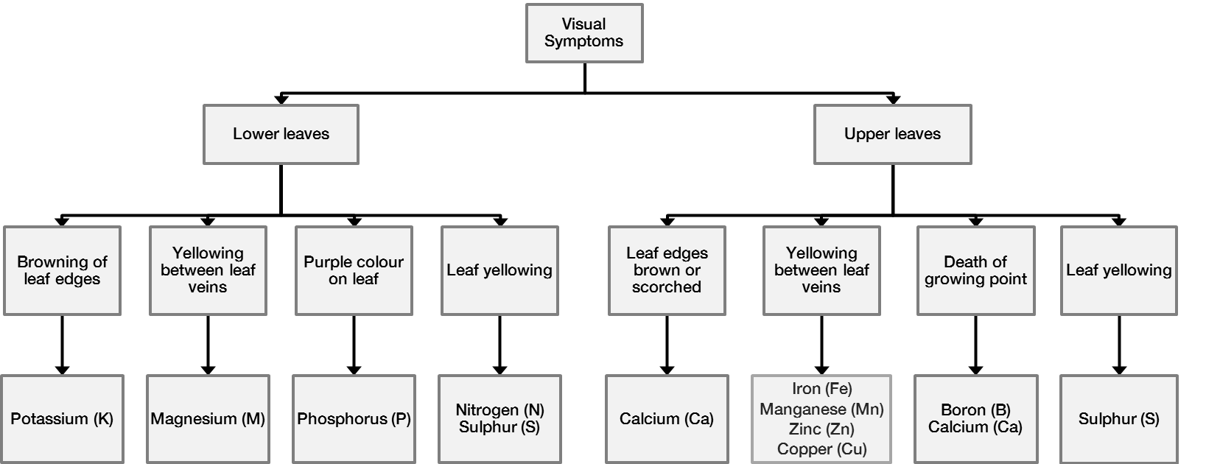
Figure 1: Visual symptoms of nutrient deficiencies.
Source: Adapted from Fairhurst (2012)
Table 1 Common N fertilizers.

Fertilizer material | Nutrient content (%)
Fertilizer material | N | P₂O₅ | K₂O
Ammonium sulphate | 21 | 0 | 0
Calcium ammonium nitrate (CAN) | 21 | 0 | 0
Urea | 46 | 0 | 0
Monoammonium phosphate | 11 | 52 | 0
Diammonium phosphate (DAP) | 18 | 46 | 0
NPK fertilizers | vary | vary | vary

Most soluble nitrogen fertilizers are essentially equal in effectiveness for crops if incorporated in well-drained soils. The most important side-effects of N fertilizers are: (i) soil acidifying effect of ammonium and urea fertilizers and (ii) the temporarily high salt concentration.
For efficient fertilizer N use with little loss, apply the fertilizer when plants are in a vigorous growth stage. Otherwise, the nitrate may leach below the root zone. This loss, together with competition from weeds and micro-organisms, reduces nitrogen use efficiency.

Phosphate fertilizers
Mineral fertilizers are the common source of P but manure also contains P. Application of P is second to N in quantity of nutrient applied for most crop production. Examples of phosphate fertilizers are presented in Table 2 below.

Table 2: Examples of phosphate fertilizers.

Fertilizer material | Nutrient content (%)
Fertilizer material | N | P₂O₅ | K₂O
Single superphosphate (SSP) | 0 | 18 | 0
Triple superphosphate (TSP) | 0 | 46 | 0
Monoammonium phosphate | 11 | 52 | 0
Diammonium phosphate | 18 | 46 | 0
NPK | vary | vary | vary
Rock phosphate | 0 | vary | 0

Potash fertilizers
Application of organic and inorganic K sources may be required to ensure adequate plant available K, although soil K reserves are often adequate so K application does not benefit crop performance. Common K fertilizers are water-soluble (Table 3).
Table 3: Examples of potassium fertilizers.

Fertilizer material | Nutrient content (%)
Fertilizer material | N | P₂O₅ | K₂O
Muriate of potash (MOP) | 0 | 0 | 60
Sulfate of potash | 0 | 0 | 48
Nitrate of potash | 13 | 0 | 44
NPK fertilizers | vary | vary | Vary

Fertilizer content and interpretation
Fertilizers differ in nutrient types and amounts. The nutrient content of the fertilizer is indicated on the bag label in the form of a series of numbers. For a fertilizer that contains only one nutrient, the percentage composition of the nutrient is indicated followed by a symbol of the nutrient (Photo 1). Where the fertilizer contains more than one macronutrient, the percentage content of each nutrient will be indicated on the bag.
For nitrogen (N) supplying fertilizers, the content is indicated in nutrient form (N) while for phosphorus (P) and potassium (K) supplying fertilizers the content indicated is usually in the oxide forms, P₂O₅ and K₂O. So if a fertilizer is labelled 12:6:6 it means that 100 kg of the fertilizer contains 12 kg of N, 6 kg of P₂O₅ and 6 kg of K₂O.
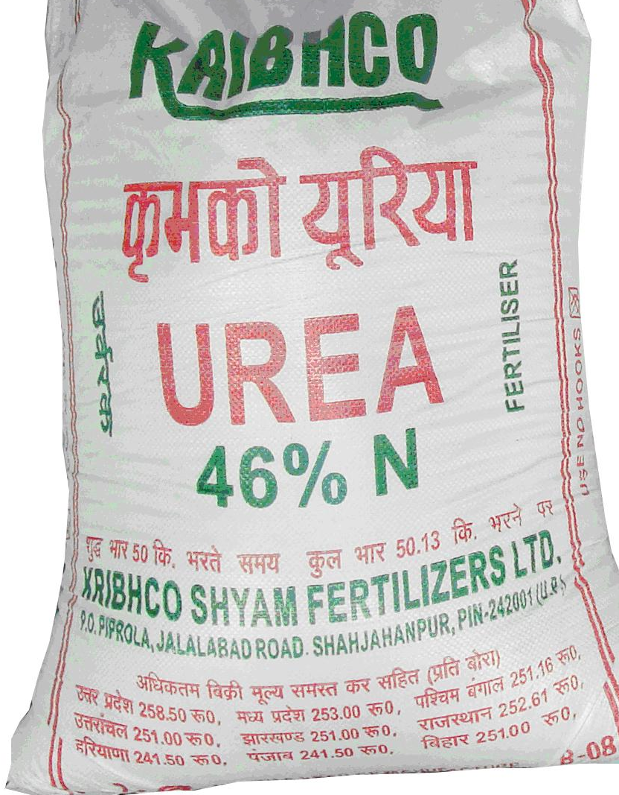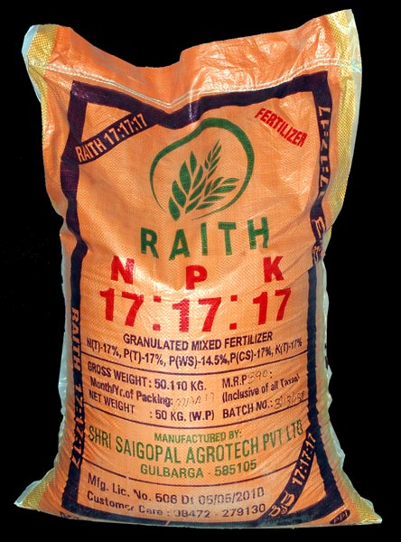
Photo 1. Fertilizer labels showing percentage nutrient content.
Converting plant nutrients (from oxide to elemental and vice versa)

Conversion factors for those plant nutrients that may be expressed in the elemental
or oxide form are shown in Table 4.

Table 4. Conversion factors of plant nutrients.

From oxide to elemental |  |  |  |  | From elemental to oxide
P₂O₅ | x | 0.44 | = | P | P | x | 2.29 | = | P₂O₅
K₂O | x | 0.83 | = | K | K | x | 1.20 | = | K₂O
CaO | x | 0.71 | = | Ca | Ca | x | 1.40 | = | CaO
MgO | x | 0.60 | = | Mg | Mg | x | 1.66 | = | MgO
SO₃ | x | 0.40 | = | S | S | x | 2.50 | = | SO₃
B₂O₃ | x | 0.31 | = | B | B | x | 3.22 | = | B₂O₃

Fertilizer application terminologies
a) Fertilizer application time

Split application
This means splitting the total amount of fertilizer to be applied into several smaller applications at different growth stages of the plant. For instance, if the recommended rate is 50 kg N/ha, 15 kg/ha can be applied at planting and 35 kg/ha later in the season at the time of vigorous plant growth. Especially, for fertilizer N, this reduces nutrient losses and improves fertilizer use efficiency.

Basal/starter application
This is when the fertilizer is applied at planting. All the fertilizer can be applied as basal (e.g. for P) or a second application can follow later in the growing season (e.g. for N). Basal fertilizers are usually incorporated into the seedbed at planting.
Top dress
This is fertilizer that is applied several weeks after the crop has germinated. It is also called side dress.
b) Fertilizer application method

Broadcast application
With broadcast application fertilizer is spread on the surface where it may be incorporated into the soil or not. It is mainly done before sowing or in the standing crop. This method is generally easier and can be combined with other operations. It has low labour requirements, but fertilizer recovery by the crop may be reduced compared with other methods.

Band application
With band application fertilizer is placed alongside the row and close to the root zone (5-8 cm below the soil surface) where the chances of it being taken up by the crops are higher. This method is especially good when there are limited quantities of fertilizers or less soluble fertilizer (e.g. phosphorus); however, it is laborious.

Spot or point application
Here fertilizer is placed in small amounts at each planting station; e.g. DAP placed in the hole prior to planting the seed or after a specific interval within a row. Care should, be taken not to place fertilizer too close to the seed to avoid the fertilizer ‘burning’ the seed. Point application is sometimes done after crop emergence.

Foliar sprays
Here fertilizer is applied through spraying on leaves using a knapsack sprayer. This is mainly used when applying micronutrients, especially on horticultural crops (flowers, vegetables, citrus). Fertilizers applied as sprays must be in very dilute solutions to avoid scorching of the leaves. However, farmer must spray repeatedly because of the low concentrations of fertilizers. Foliar applied fertilizers have the advantage of fast action because nutrients are absorbed through the leaves but are a relatively expensive means of nutrient application.

Incorporate
This means covering fertilizers with soil to minimize nutrient loss through erosion and volatilization (e.g. ammonia). Fertilizers such as ammonia and urea should always be incorporated into the soil immediately after application to minimize loss of N through volatilization.

The 4Rs
The 4R nutrient stewardship concept is a simple way of expressing best management practice for fertilizer use. The 4R approach aims to enhance environmental protection, increase productivity and farmer profitability, and improve sustainability. The concept is to use the right fertilizer source, at the right rate, at the right time, with the right placement.

Organic fertilisers
Organic fertilizers are carbon-rich materials derived from non-synthetic organic material of vegetable or animal origin. Organic fertilizer products [residues of plants, animal and human waste] are useful suppliers of nutrients and contribute to maintenance or improvement of soil organic matter.

Types of organic fertilizers
Farmyard manure (FYM)
Farmyard manure is composed of dung and urine of cattle with straw or other bedding materials. It often contains much soil. Plant nutrients found in FYM depend on:
- the nutrient content of the feed given to the animals
- the nutrient content of the straw used for bedding
- the degree of composting or rotting of the straw
- the losses of ammonia by volatilization
- the losses of soluble compounds by leaching
- the soil content
- the water content
Farmyard manure is of variable value to crops. It can be applied to all soils and crops before or after sowing the crop. It can be spread uniformly over the field or be band or point placed, and then incorporated in the soil.
Poultry manure
Generally contains high nitrogen, phosphorus and low potassium. It can be applied in the same way as FYM but incorporation when applying is more critical than for FYM because of potential for ammonium-N loss.
Liquid manure
Liquid manure is made by soaking animal dung or chopped grass, soft green leaves and branches, or fermenting animal urine for 14 days. The manure is then diluted before applying it in the field. It provides crops with natural plant nutrients quickly during the growing season and it is best to apply liquid manure every two or three weeks. It is a very laborious means of nutrient application.
Compost
Organic wastes such as crop residues, weeds and organic household refuse are converted into compost by a controlled process of decomposition. Compost is made by piling up organic residues or organic materials mixed with a small amount of soil, moistening the materials in the pile and letting these materials undergo biological decomposition. The quality of the compost, i.e. the quantities of nutrients in the manure, depends on the quality of the organic materials being composted. Compost is used in the same way as FYM.
Green manure
Green manuring involves growing crops, such as mucuna, lablab or canavalia, and incorporating them into the soil before they reach maturity when preparing land prior to planting to improve the physical and chemical properties of the soil. A variation on green manures is cover crops, which may or may not be legumes, and are often incorporated into the soil. Major benefits from the use of green manure cover crops in crop rotations include:
- adding organic matter to the soil
- adding biologically fixed nitrogen to the soil if the green manure is a legume
- reducing the loss of mineral nitrogen by leaching
- covering and protecting the soil from soil erosion as well as conserving soil water.
Crop residues
Crop residues contain nutrients. The quality of the crop residues depends on the crops contributing the residues. For instance, residues from legumes are of better quality than those from cereal crops due to the higher nitrogen content in the legumes. Crop residues can be composted, used as mulch or incorporated into the soil during land preparation.

Quality of organic materials
Organic materials vary a lot in quality which is a major constraint in using them for soil fertility management. For instance, the quality of animal manure depends on age of the animal, the quality of feed and manure management. Table 5 illustrates the nutrients contained in a variety of organic materials.
Table 5: Average nutrient content (%) on a dry matter basis of selected organic materials collected in Eastern and Southern Africa.

Material | N (%) | P (%) | K (%)
Crop residues
Maize stover | 0.6 | < 0.1 | 0.7
Bean trash | 0.7 | < 0.1 | 1.4
Banana leaves | 1.9 | 0.2 | 2.2
Sweet potato leaves | 2.3 | 0.4 | --
Sugarcane trash | 0.8 | < 0.1 | 1.0
Rice straw | 0.7 | 0.1 | 1.4
Coffee husks | 1.6 | 0.4 | --
Refuse compost | 2.0 | 0.7 | 2.0
Animal manures
Cattle
High quality (cattle fed on concentrates) | 2.3 | 1.1 | 0.6
Low quality | 0.7 | 0.1 | 0.8
Chicken | 2.4 | 0.7 | 1.4
Leguminous trees (leaves)
Calliandra calothyrsus | 3.4 | 0.2 | 1.1
Gliricidia sepium | 3.3 | 0.15 | 2.1
Leucaena leucocephala | 3.4 | 0.15 | 2.1
Sesbania sesban | 3.4 | 0.15 | 1.1
Senna spectabilis (non-N₂-fixing) | 3.3 | 0.2 | 1.6
Non-leguminous tree and shrubs (leaves)
Chromolaena ordorata | 3.8 | 0.24 | 1.5
Grevillea robusta | 1.4 | < 0.1 | 0.6
Lantana camara | 2.7 | 0.24 | 2.1
Tithonia diversifolia | 3.6 | 0.27 | 4.3
Leguminous cover crops
Crotalaria ochroleuca | 4.2 | 0.16 | 0.9
Dolochos lablab | 4.1 | 0.22 | 1.3
Mucuna pruriens | 3.5 | 0.2 | 0.7
Nutrients (kg) required to produce 2 tonne grain + 3 tonne stover of maize | 80 | 18 | 60
Source: Palm et al. (1997)

Biological nitrogen fixation
Biological nitrogen fixation (BNF) is the process of converting atmospheric nitrogen (N₂) by microorganisms to a form useful to plants. Symbiotic nitrogen fixation which is done by the association between certain bacteria and legumes roots is most important and beneficial agriculturally. Symbiotic nitrogen fixation can be managed to benefit agricultural systems.
The legume-rhizobia symbiosis
The nitrogen fixing symbiosis most beneficial to agricultural is that between the soil bacteria known as rhizobia and legumes. The legume family is quite large and includes grain legumes such as beans, groundnut, soybean, cowpea and pigeon pea. It also includes herbaceous legumes such as mucuna, canavalia, lablab; forage legumes such as lucerne; and tree species such as leucaena.
Legumes develop small outgrowths called nodules on their roots. Nodulation is enhanced by P application and inoculation with rhizobia.
BNF can supply the legume with most or all the N it needs for optimum yield. With effective nodulation, there may be no need to apply N fertilizers. Some crops can form effective nodules with more than one type of rhizobia while others nodulate with specific rhizobia. For example, cowpea can form nodules with a wide range of rhizobia while chickpea and some soybean varieties only form effective nodules with specific strains of bacteria.
Rhizobia may be present in the soil but can fail to produce nodules or to fix adequate N for the plant’s growth either because of low numbers or poor capacity to fix N. To improve BNF, the seeds or the seedbed can be inoculated with the recommended rhizobia. Rhizobium inoculants are produced commercially for most of the agriculturally important legumes.

Legumes in crop rotations
Legumes (e.g. grain, herbaceous) can add significant amounts of N to the soil which can benefit the following crop, although it is more common to remove more N in harvest and forage legumes than was fixed by the crop. Legumes, however, differ in the amount of nitrogen they fix and in the amount of nitrogen taken in the grain.

Use of legumes as green manure crops or improved fallow
Growing legumes such as mucuna, lablab or canavalia and then working the entire crop into the soil when it is still green adds easily decomposed organic material for release of much N. The increase in sorghum yield and the returns obtained following a cowpea or mucuna fallow illustrates the importance of legumes in soil fertility management and also in increasing crop yield (Table 6).
Table 6: Sorghum yield and returns with crop rotation, mucuna and N fertilizer.

Previous crop and N rate | Grain yield tonnes per ha | Returns above fertilizer cost ‘000 UGSH per ha
Sorghum, no N | 1.21 | 374
Cowpea, no N | 2.01 | 536
Sorghum, 30 kg N per ha | 2.33 | 372
Mucuna, no N | 2.75 | 455
Source: Kaizzi et al. (2007).

Use of herbaceous legumes as cover crops
Fast growing leguminous crops, such as mucuna and Arachis pintoi, are grown as cover crops between rows of perennial crops to protect the soil from erosion. In addition to protecting the soil, the cover crop fixes N which is added to the soil and benefits the perennial crop.
Use of leguminous trees and forage species as improved fallows
Leaving land to rest to restore soil fertility has been a common practice in SSA. However, it is no longer possible in many parts of SSA due to increasing population pressure. The alternative is a relay cropping where the legume species are planted when the food crop, usually an annual, is still in the field but when it is well established and the legume will not compete significantly for water, nutrients and other resources with the food crop. After the crop has been harvested, the legume continues to grow for 3 months in the case of short-term legumes like canavalia, crotolaria, mucuna, or for 6 months or for 1 year in the case of agro-forestry trees like caliandra. When the land is needed for the next crop, the legume is cut and incorporated into the soil during the seedbed preparation. The main advantage of improved fallows is that soil fertility is restored within a fairly short time.

4. FERTILIZER RECOMMENDATIONS
The current fertilizer recommendations across SSA were developed with the intent of maximizing yield or profit per hectare and are sometimes appropriate for farmers with the financial ability to apply fertilizer across all of their cropland to maximize net returns per hectare. Average fertilizer use in SSA is far less than recommended due to inefficiencies across the fertilizer value chain with poor accessibility, high procurement costs and low financial capacity of farmers. Furthermore, existing recommendations do not allow smallholders to maximize net returns on small investments.
Effect of price on economically optimum fertilizer recommendation
The cost of fertilizer (C) can be expressed as the amount of produce (P) which a farmer has to sell to buy 1 kg of nutrient - the C:P ratio. The C:P ratios are generally high for most cereals and relatively lower for upland rice and legumes because of the higher farm gate price of the latter.
For example, if cost of urea (46% N) fertilizer is USD 35 per 50 kg bag and price of maize is USD 0.12 per kg, then:
Price of 1 kg urea = 35/50 = USD 0.70
Price of 1 kg N = 0.7 x 100/46 = USD 1.52
Cost of nutrient/farm gate price maize = 1.52 / 0.12 = 13
So, the cost of 1 kg of N is equivalent to the value of 13 kg of maize grain. But if the fertilizer cost was compared with the value of rice, assuming the price of rice was USD 0.35 per kg, then:
Cost of nutrient/farm-gate price of rice = 1.52 / 0.35 = 4.3
So, the cost of 1 kg of nitrogen is equal to 4.3 kg of rice.
If cash is not a constraint, the amount of fertilizer that maximizes returns per area of land (Economically Optimum Rates, EOR) can be applied. But if finance is a constraint, which it almost always is, the amount of fertilizer that maximizes returns per money invested, which is less than the EOR, should be applied.
If farm-gate prices of produce decline or fertilizer prices increase, farmers have to apply less fertilizer to maintain the EORs. For example, in trials carried out in Uganda (Figure 3), the EOR for maize decreased from 44 to 33 kg N per hectare as C:P increased from 10 to 20. For cash constrained farmers, maximum benefits, i.e. highest benefit-to-cost ratio [region indicated with red oval in Figure 2] could be obtained by applying less than 30 kg N per hectare.
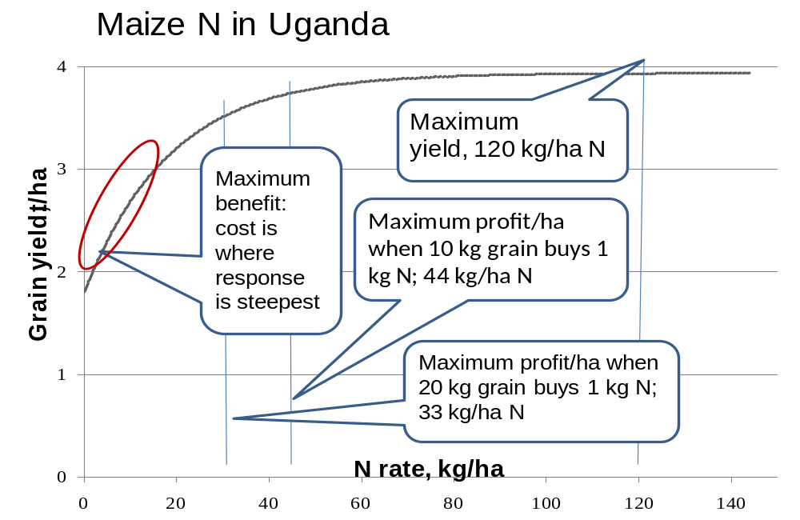
Figure 2. Maize yield response to N fertilizer and effect of change in cost of nutrient to farm gate price on the economically optimum amount of fertilizer.

5. DECISION SUPPORT TOOLS IN SOIL FERTILITY MANAGEMENT
Fertilizers are a component of ISFM. Good technical advice on fertilizer use as well as the optimal choice of combinations of crop-nutrient-application rate can greatly increase net returns on fertilizer use. Decision support tools can be used by extension staff and other frontline workers to provide farmers with advice on right amount of fertilizer to apply and the best crop on which to apply it so that farmers will get the highest returns.
For instance, the cost of fertilizer N used in maize production is often 15 to 20 times that of maize grain (kg/kg) for smallholders in SSA compared to less than 5 in the United States. Thus, cash-constrained smallholders typically cannot apply fertilizer to all of their cropland if they apply at rates to maximize net returns per hectare. Often, they can apply fertilizer on only a small part of their farm and therefore need to make choices that maximize the benefit-to-cost ratio. This implies that applications should be based on the crop-nutrient- rate combinations that give the greatest net returns for their investment capacity.

Fertilizer Optimization Tool
As a result of initial research collaboration in Uganda between the National Agricultural Research Organisation, (NARO), the Alliance for a Green Revolution in Africa (AGRA) and University of Nebraska–Lincoln (UNL), and later through CABI, UNL and 13 national agricultural research services in SSA, a series of decision tools known as Fertilizer Optimizer Tools [FOT] (Figures 9 and 10) were developed and are being adopted by the 13 Optimizing Fertilizer Recommendations in Africa (OFRA) project countries.
Through linear programming the FOT generates crop-nutrient-rate combinations that optimize returns on investment, when inadequate monetary resources limit fertilizer use. The linear programming uses Excel with the Solver add-on.
The tool achieves the objective function of maximizing total expected net returns to fertilizer use by determining the optimal combination of crop-nutrient-rates, subject to the budget and response function constraints.
The costs for the total amount of fertilizer recommended cannot exceed the financial resources available for investment.
Once the optimal crop-nutrient-rate combinations have been determined, the results are displayed including the optimized crop-fertilizer application rates for the 15 possible crop-nutrient combinations (5 crops x 3 nutrients), expected effects on yield and net returns to fertilizer use, and total expected net returns to investment in fertilizer use.
Each set of constraints imposed by the user – how much money the farmer is willing to invest in fertilizers, crops to grow and area planted, plus the expected price of the produce at harvest - delivers a unique, but optimized solution based upon attributes pertinent to the farmer’s operation.
Microsoft Solver
The Solver add-in must be enabled for the Fertilizer Optimization spreadsheet to function appropriately. When enabled the Solver add-in appears under the Data tab on the Quick Access Toolbar.

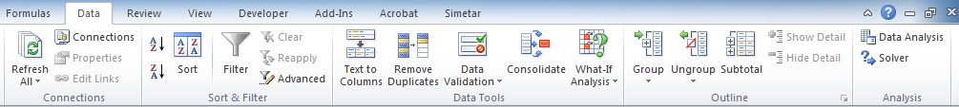
Data
Tab
Solver
Add-in
Adding Solver Add-in to Excel
The following series of steps show how to add the Solver Add-in to the Data tab on the Quick Access Toolbar in Excel:

Step 1
Step 2
1) Select the File tab on the Quick Access Toolbar
2) Select Options on File drop down menu
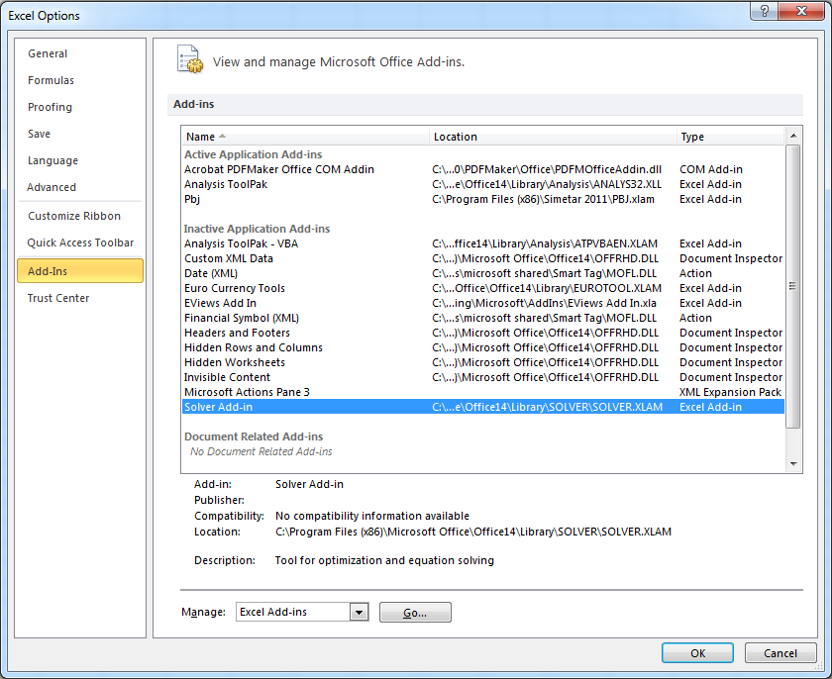
Step 3
Step 4
Step 5
3) Select Add-Ins on the left hand side of the Excel Options window
4) In the Add-Ins drop down list select the Solver Add-in options
5) Select Go
After selecting Go the Add-Ins options window appears
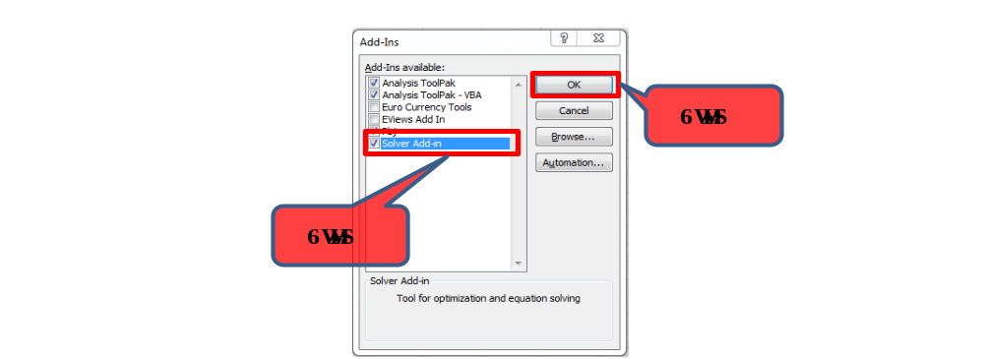

How to get the Fertilizer Optimization Tool
Fertilizer Optimization Tools have been developed for different AEZs in the respective countries and can readily be obtained from national soil fertility research teams. The Excel version is then loaded on the computer and the user is advised to go through the steps (to enable the solver) outlined above so that the FOT can run.
The user should first enable the macros before enabling the solver by following the instructions in the help worksheet found in the FOT Excel file.
How to use the Fertilizer Optimization Tool
Input
In the input panel (Figure 3) the user enters the estimated area to be planted and the expected market price for each crop, the prices of available fertilizers and the amount of money the farmers want to invest in fertilizer. Clicking on the ‘Optimize’ button then runs the optimization calculations.
The output panel (Figure 4) displays the recommended fertilizer rate for each crop, the expected yield increases, the net returns for each crop and the expected total net return to investment in fertilizer. Seasonal variation in the profitability of fertilizer use requires ready access to current information on fertilizer prices and grain market prices to better determine the Economically Optimum Nutrient Rate (EONR) for the current season.
The FOT presents an excellent opportunity to increase fertilizer use in crop production as it takes into account both agronomic and economic constraints. The approach strives to maximize profitability of fertilizer use through consideration of the farmer’s financial constraint, costs and prices of inputs and outputs, and farmer’s cropping system. It identifies the crop-nutrient-rate combinations expected to maximize returns on investment in fertilizer.
Example: Outputs from the FOT for farmers investing Ugandan shillings (UGSH) 200,000 (USD 60) and UGSH 350,000 (USD 100) in the Eastern Uganda Low Altitude AEZ
The following section illustrates the outputs from the FOT for farmers with UGSH 200,000 and 350,000 to invest in fertilizers, respectively.
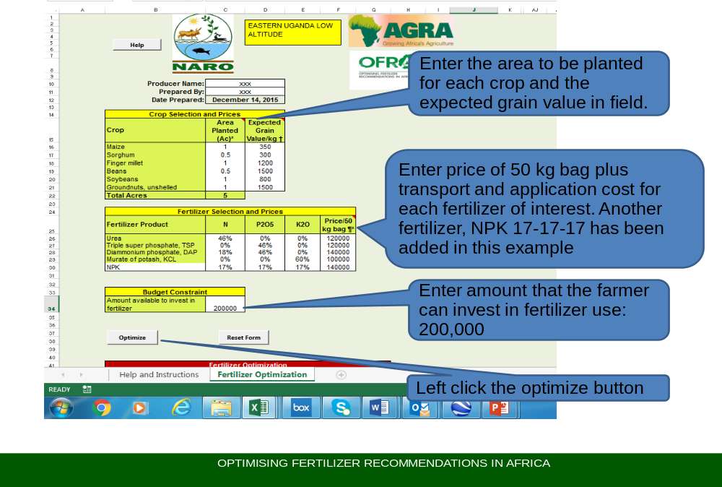
Figure 3: FOT panel for data inputting.
Following the steps described above, Figures 4 and 5 display the output. So, for the farmer investing UGSH 200,000 in fertilizer the total return on investment will be about UGSH 1.2 million (Figure 4). If the farmer invests UGSH 350,000 in fertilizer then the return on investment increases to UGSH 1.45 million (Figure 5); the benefit:cost ratio decreases but it is still profitable.

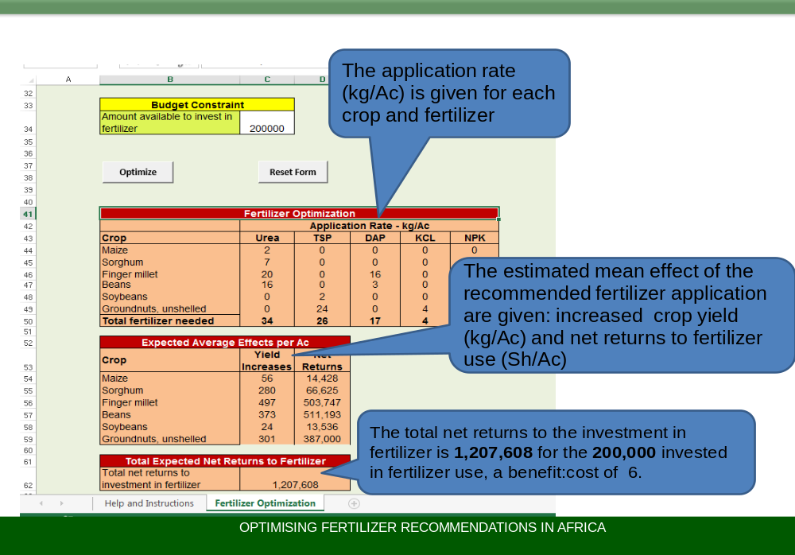
Figure 4: FOT panel displaying output for investing UGSH 200,000 in fertilizer.
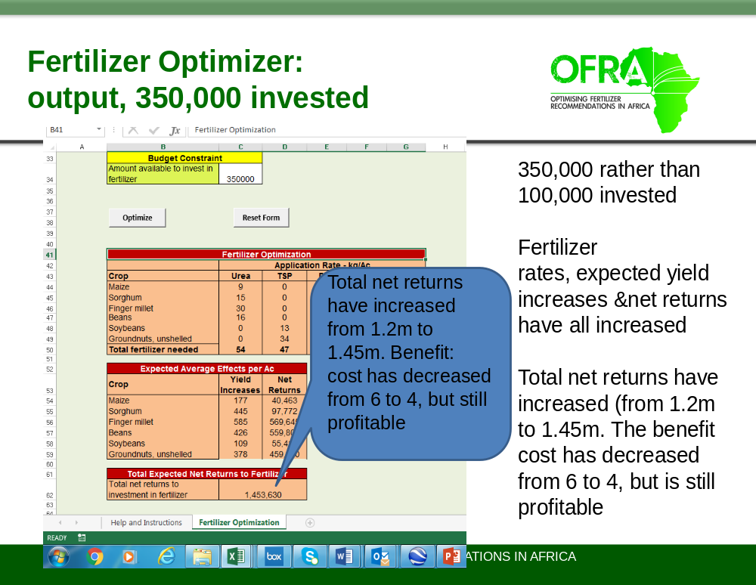
Figure 5: FOT panel displaying output for investing UGSH 350,000 in fertilizer.
Tips and points to remember when using the tool
- Sometimes fertilizer rates suggested by the tool may be very low, below 25 kg per hectare or 10 kg per acre, which is too small an amount to be worthwhile to apply. For example in Figure 4 it suggested 2 and 7 kg/ha of urea for maize and sorghum respectively, 3 kg/ha DAP to bean, 2 kg/ha TSP to soybean, and 4 kg/ha KCl to groundnut. If this situation occurs it would be better to:
- Reallocate this money to other crop-nutrients such as by increasing: urea applied to finger millet and bean by 5 and 4 kg/ha, respectively; DAP applied to finger millet by 3 kg/ha; and TSP applied to groundnut by 2 kg/ha. The 4 kg/ha of KCl for groundnuts has a value of 8000 UGSH which could be used to further increase DAP applied to finger millet by 3 kg/ha.
- Avoid mixing two or more fertilizers together for ease of application. The more dense fertilizer will tend to sink to the bottom of the container. It is better to apply each fertilizer separately.
- Recommended fertilizer application rates are inevitably low with a small investment. However, returns on investment will be high. The increased net return will enable a farmer to have increased income to gradually increase fertilizer use for future crops.
Since socio-economic factors limit fertilizer use, the FOT has a great potential to support decision making at farm level on where to place fertilizer in mixed cropping systems and the best crop-nutrient combinations to generate maximum economic returns.

6. FERTILIZER RECOMMENDATIONS IN ISFM CONTEXT
The output of the FOT is the optimum amount of fertilizers which a farmer should apply to maximize profit with the available resources but with some exceptions. Fertilizers are not the sole source of nutrients, so it is important that some other practices of the farmer be considered when advising on the amount of fertilizers that should be applied. We need to consider:
- The time, amount and quality of any recent manure application
- If the previous crop was a legume
- Legume–cereal intercropping
- Use of green manure
The fertilizer recommendation obtained from the FOT needs to be adjusted using the ISFM framework displayed in Table 8. The substitution values in the table have been developed for Uganda. However, this framework can be adjusted based on available information (from research or expert opinion) so as to develop the nutrient substitution result for each ISFM component relevant to other countries and/or agro-ecological zones. Fertilizer rates may also be adjusted for soil test values.
Table 8: Fertilizer/nutrient substitution and soil test implication framework; an example from Uganda.

ISFM practice | N | P₂O₅ | K₂O
ISFM practice | Nutrient reduction, kg/ ha or %
Previous crop was a green manure crop | 100% | 100% | 100%
Fresh vegetative material (e.g. pruning of Lantana or Tithonia) applied, per 1 t of fresh material | 5 kg | 2 kg | 3 kg
Farmyard manure per 1 t of dry material | 0 kg | 2 kg | 3 kg
Residual value of FYM applied for the previous crop, per 1 t | 0 kg | 1 kg | 1 kg
Dairy or poultry manure$, per 1 t dry material | 5 kg | 3 kg | 8 kg
Residual value of dairy & poultry manure applied for the previous crop, per 1 t | 2 kg | 2 kg | 1 kg
Compost per 1 t dry material applied | 3 kg | 3 kg | 5 kg
Residual value of compost applied for the previous crop, per 1 t | 3 kg | 2 kg | 1 kg
Rotation | 0% reduction but more yield expected
Cereal-bean intercropping | Increase P₂O₅ by 8 kg/ha, but no change in N & K compared with sole cereal fertilizer
Cereal-other legume (effective in N fixation) intercropping | Increase P₂O₅ by 12 kg/ha, reduce N by 10 kg/ha, & no change in K compared with sole cereal fertilizer
If Mehlich III P >15 ppm | Apply no P
If soil test K <100 ppm | Band apply 50 kg/ha KCl

7. FERTILIZER CALIBRATION TOOL

Smallholder farmers in SSA do not have access to scales to weigh out the fertilizer. Also they may not know the exact size of their plots to implement fertilizer recommendations. To overcome this problem, a fertilizer calibration tool (Figure 6) has been developed. The tool converts the recommended fertilizer rate, which is often in kg of fertilizer per acre or hectare, into a more farmer-friendly measure. Therefore extension service providers should advise farmers how to calibrate their sight and feel to apply a fertilizer at the desired rate using readily available containers, e.g. plastic water bottles, lids of water bottles, other bottle caps, tins and match boxes. The expectation is that farmers will use their hands rather than these units for actual application, but they should be advised to periodically check their calibration with the measuring unit.
This is illustrated with an example from West Africa using commonly available calibration measures – a plastic water bottle lid and a Gino brand tomato paste tin. The volume of a measurement unit is determined by filling with water and determining the weight of the water. Fertilizers have different density and the weight in a particular volume varies with the fertilizers (Table 9): the volume of the measure multiplied by the density of the fertilizer gives the weight of fertilizer in that container. In the case of plastic water bottles, these can be cut to different heights to create a suitable measure.
Figure 6. Fertilizer calibration tool.
Table 9: Weight (g) of fertilizers in measuring containers commonly available in West and Central Africa.
 | Plastic water bottle lid, volume 8 ml  (g) | Gino tomato paste tin, volume 70 ml  (g)
DAP | 13.0 | 113.0
KCl | 15.8 | 139.0
NPK 15-15-15 | 10.5 | 92.0
SSP | 9.0 | 78.4
TSP | 17.8 | 155
Urea | 10.6 | 92.4
ZnSO4 | 15.8 | 139.0

The approximate distance to be covered by given amount fertilizer is obtained basing on the application method as illustrated below.

Point placement of fertilizer
Points per measure (PM)
PM = Measure weight g (M) / [Fertilizer rate kg/ha (R) * 10,000 m² / 1000 g / (row spacing m (RS) * point spacing m (PS))]
PM = M / R * 10 / (RS * PS) = Points per calibration measure
Example:
1. Apply 50 kg per ha DAP (R).
2. Plant density is 53,300 plants per ha: spacing 0.25 x 0.75 m (PS x RS)
3. Calibration measure holds 13 g (M)
Therefore, 13 / 50 * 10 / (0.25 * 0.75) = 13.9 points/calibration measure, which can be rounded up to 14 points per calibration measure
Band placement of fertilizer
Meters/measure (MM)
MM = Measure weight g (M) / [Fertilizer rate kg/ha (R) *10,000 m² /(1000 g/ (row spacing m (RS))]
PM = M / R * 10/RS = Meters/measure
Example:
1. Apply 50 kg per ha DAP (R)
2. Row spacing is 0.5 m (RS)
3. Measure holds 13 g (M)
Therefore, 13 / 50 * 10 / 0.50 = 5.2 meters per calibration measure
Broadcast application of fertilizer
Meters/measure (MM)
MM = Measure weight g (M) / [Fertilizer rate kg/ha (R) *10,000 m² /1000 g / pass width m (PW)]
MM = M / R * 10 / PW
Example:
1. Apply 50 kg/ha DAP (R)
2. Pass width is 2.25 m (PW)
3. Measure holds 113 g (M)
Therefore, 113 / 50 * 10 / 2.25 = 10 meters (2.25 m wide), per calibration measure.

ADDITIONAL READING MATERIALS
Information on good management practices can be accessed from http://www.cabi.org/ashc/

Appendix: DEVELOPMENT AND REVISION OF PAPER VERSIONS OF FERTILIZER OPTIMIZATION TOOLS (FOT)
The FOT currently runs on a laptop computer, but very often frontline extension workers and farmers will not have access to computers. To extend the benefits of the FOT to these people a simple paper-based version of the tool can be developed, for example at national or regional level where computers are available.
Different paper based FOTs need to be produced for each agro-ecological zone for which a FOT has been developed. New paper-based FOTs need to be developed each season to reflect changing prices of fertilizer and outputs.
To develop the paper-based FOT
- Use the Excel FOT.
  - Ensure the crop values (considering expected ‘farmgate’ price and value if kept for home consumption) and fertilizer use costs (price plus costs of procurement and application” as entered in the FOT are correct.
  - Enter 1 ac or 1 ha for each crop.
  - Run the FOT using a very high financial constraint (equivalent of about USD 20,000 in example below) to ensure the recommendations are at levels to maximize net return per acre or hectare.
  - Optimize.
  - Get the sum of the total amount (c51-g51) x its cost for each fertilizer product (f26-f30). This sum is the money needed exactly to maximize net returns per ac or ha.
  - See images for Central Kenya FOT.
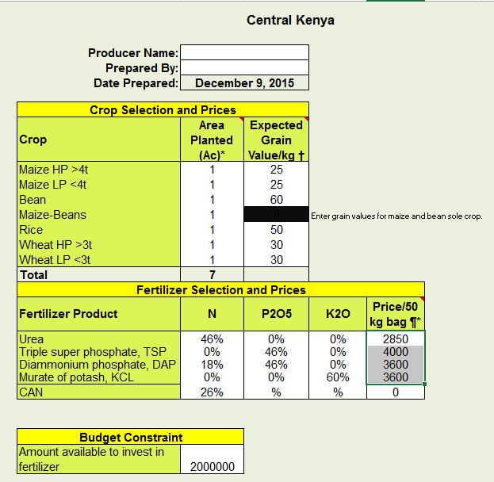
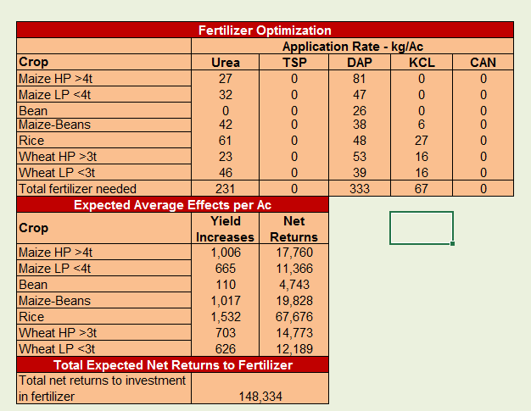
- The calculation of total costs of fertilizer to maximize net return per ac are shown below, followed by amount of KSh to be the financial constraint for financial constraint level 1, 2 and 3 (1/3, 2/3, 3/3 of total costs):
 | Urea | TSP | DAP | KCl
Fertilizer needed to maximize net return per acre(kg) | 231 | 0 | 333 | 67
Cost per 50 kg fertilizer (KSh) | 2850 | 4000 | 3600 | 3600
Total cost for each fertilizer (KSh) | 13170 | 0 | 23975 | 4790
Total fertilizer cost (KSh) |  |  |  | 41935
Money for financial level 1 (KSh) |  |  |  | 13979
Money for financial level 2 (KSh) |  |  |  | 27957
Money for financial level 3 (KSh) |  |  |  | 41936

- Run the FOT for each of these financial constraints to determine fertilizer levels to use for each financial constraint level.
Financial constraint level 1: about KSh 14,000 (USD 140) for 7 acres
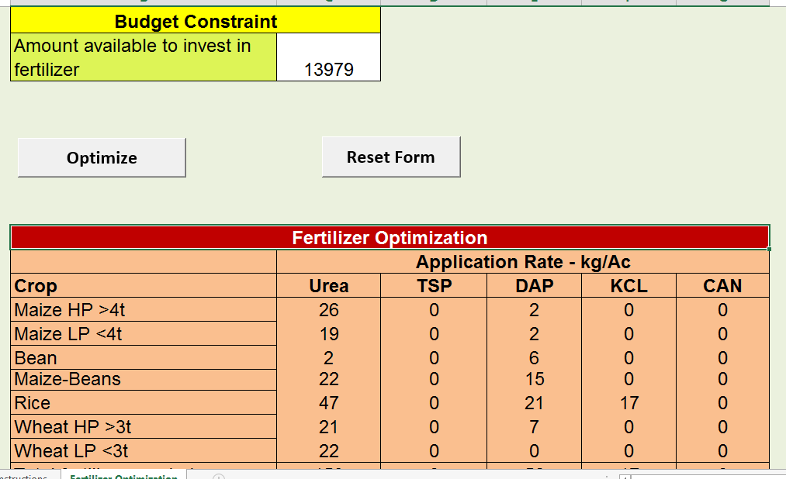
Financial constraint level 2: about KSh 28,000 (USD 275) for 7 acres
Budget Constraint
Amount available to invest in fertilizer |  | 27957


Fertilizer Optimization
 | Application Rate - kg/Ac
Crop | Urea |  | TSP | DAP | KCL |  | CAN
Maize HP >4t | 23 |  | 0 | 48 | 0 |  | 0
Maize LP <4t | 25 |  | 0 | 23 | 0 |  | 0
Bean | 1 |  | 0 | 16 | 0 |  | 0
Maize-Beans | 31 |  | 0 | 26 | 1 |  | 0
Rice | 60 |  | 0 | 31 | 22 |  | 0
Wheat HP >3t | 30 |  | 0 | 28 | 8 |  | 0
Wheat LP <3t | 35 |  | 0 | 15 | 8 |  | 0
Financial constraint level 3: about KSh 42,000 (USD 410) for 7 acres
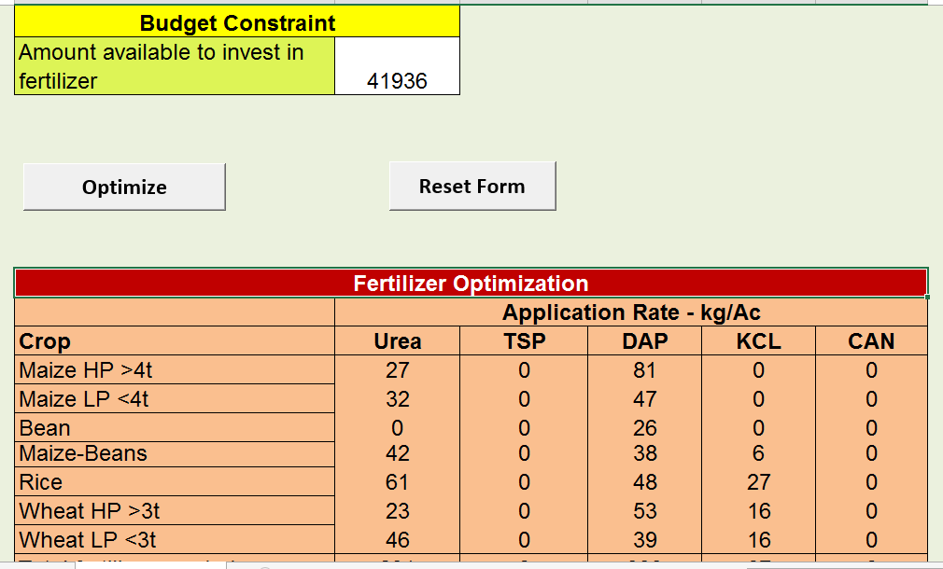
- Use these 3 fertilizer levels to construct the paper FOT as shown in the below examples.
- Determine your calibration measuring units and their volume. In the example below, the measuring units are from Ghana: the smaller measure, such as a water bottle lid, should be of less than 10 ml – in this example it is 8 ml; the second should be between 40 and 80 ml – in this example the Gina tomato can/tin is 70 ml. Both measures should be readily available in rural areas. These units are to help the farmer calibrate visually and by feel the rate of application but, beyond this initial and occasional verification calibration, actual application is likely to be by hand and not using the unit. Change as necessary below.
- After confirming that the assumptions are correctly written, proceed as below. You may want to change what I have written for the 4R practices. The calibration will need to be redone with your measuring units and using the OFRA Fertilizer Calibration Tool.
- If the application rate suggested by the FOT is below 10 kg per ac (25 kg per ha), ignore that recommendation.
- For other AEZs, start with a completed and renamed paper FOT and revise for changes in the crops and fertilizer rates as determined with that AEZs FOT, and the calibrations (in parentheses).
- If you wish to substitute or partly use CAN in place of urea, do the needed calculations separately if their N cost is similar, or, below doing the ‘total cost’ FOT run, put the Urea Max’s low enough to force some N fertilizer to CAN. Consult with someone who knows how to unprotect and change UreaMax by revising FOT cells T18 to T23.
- Contact cwortmann2@unl.edu if you have questions.
Kenya Central Fertilizer Use Optimizer: paper version, November 2015 (an example)
It is assumed that:
Calibration measurement is with a
- water bottle lid (lid, 8 ml) that holds 10.6 g urea, 13.0 g DAP, 17.8 g of TSP, or 15.8 g KCl; or, a
- Gino-brand tomato tin/can (Gino, 70 ml) that holds 92.4 g urea, 113 g DAP, 155 g of TSP, or 139 g KCl.
It is assumed maize is planted with 75 cm and bean with 50 cm row spacings.
It is assumed grain prices per kg (KSh) are: 25 maize; 60 bean; 50 rice; 30 wheat.
It is assumed 50 kg of fertilize use costs (KSh): 2850 urea; 4000 TSP; 3600 DAP and KCL.
Fertilizer recommendations all in kg per acre
WAP = weeks after planting HP= high producing LP=low producing
Level 1 financial ability
Rice, broadcast 21 kg DAP and 17 kg KCl at planting (1.2 lid for 1.0 m and 1.9 m respectively, @ 2 m wide); topdress broadcast 47 kg urea at panicle initiation (1 Gino for 4.2 m @ 2 m wide).
Maize-bean intercropping, band apply 15 kg DAP at planting (1 lid for 5.0 m) and topdress band 22 kg urea 6 WAP (1 lid for 2.5 m).
Maize HP>4t, topdress band 26 kg urea 6 WAP (1 lid for 2.0 m).
Wheat (HP and LP), topdress broadcast 22 kg urea at panicle initiation (1 lid for 1 m @ 2 m wide).
Maize LP<4t, topdress band 19 kg urea 6 WAP (1 lid for 3.0 m).
Level 2 financial ability
Rice, broadcast at planting 33 kg DAP (1 lid for 1.0 m @ 2 m wide) and 27 kg KCl (1 lid for 1.0 m @ 2 m wide) and topdress broadcast 28 kg urea at tillering and 28 kg urea at panicle initiation (1 Gino for 6.5 m @ 2 m wide).
Maize-bean intercropping, band 25 kg DAP at planting (1 lid for 2.0 m) and topdress band 33 kg urea 6 WAP (1 lid for 2.5 m).
Maize HP>4t, band 28 kg DAP at planting (1 lid for 2.5 m) and topdress band 33 kg urea 6 WAP (1 lid for 1.5 m).
Wheat HP>3t, broadcast at planting 25 kg DAP (1 lid for 1 m @ 2 m wide) and topdress broadcast 31 kg urea at panicle initiation (1 Gino for 6 m @ 2 m wide).
Wheat LP<3t, broadcast at planting 19 kg DAP (1 lid for 1.5 m @ 2 m wide) and topdress broadcast 30 kg urea at panicle initiation (1 Gino for 6 m @ 2 m wide).
Maize LP<4t, band 21 kg DAP at planting (1 lid for 3.0 m) and topdress band 27 kg urea 6WAP (1 lid for 2.5 m).
Bean, band 13 kg DAP at planting (1 lid for 5.5 m).
Level 3 financial ability
Rice, broadcast at planting 48 kg DAP (1 Gino for 5.0 m @ 2 m wide) and 27 kg KCl (1 lid for 2.5 m @ 2 m wide) and topdress band 61 kg urea 6WAP (1 Gino for 3.1 m @ 2 m wide).
Maize-bean intercropping, band 38 kg DAP at planting (1 lid for 2.0 m) and topdress band 42 kg urea 6WAP (1 lid for 1.5 m).
Maize HP>4t, band 81 kg DAP at planting (1 lid for 1.0 m) and topdress band 27 kg urea 6 WAP (1 lid for 1.0 m).
Maize LP<4t, band 47 kg DAP at planting (1 lid for 1.5 m) and topdress band 32 kg urea 6WAP (1 lid for 2.0m)
Wheat HP>3t, broadcast at planting 53 kg DAP (1 Gino for 4.5 m @ 2 m wide) and 16 kg KCL (1 lid for 2.0 m @ 2 m wide), and topdress broadcast 21 kg urea at panicle initiation (1 Gino for 9.0 m @ 2 m wide).
Wheat LP<3t, broadcast at planting 39 kg DAP (1 Gino for 6.0 m @ 2 m wide) and 16 kg KCL (1 lid for 2.0 m @ 2 m wide), and topdress broadcast 23 kg urea at tillering and 23 kg urea panicle initiation (1 Gino for 8.0 m @ 2 m wide).
Bean, band 26 kg DAP at planting (1 lid for 12.5 m)

Available at http://africasoilhealth.cabi.org/tools/fertilizer-tools/the-fertilizer-calibration-tool/

