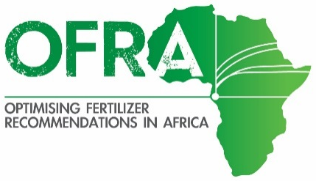
UGANDA FERTILIZER USE OPTIMIZER: Western Highlands >1800 m

The below assumes:
Cost of fertilizer use for 50 kg bag (UgSh): urea, TSP and KCl is 120,000/-; DAP is 140,000/-.
Grain values (UgSh/kg): maize 600; banana 800; finger millet 1200; Irish potato 800; sorghum 500; bean 1200; soybean 1000; and groundnut unshelled 2500.
Calibration measurement units: a Highland water bottle cap (CAP) that holds 7.5 ml, about 5.25 g urea, 8.25 g DAP, TSP, or KCl; and Highland water bottle cut at 2 cm (2-cm bottle) holds 59.3 ml, 41.5 g urea, and 65.2 g of DAP, TSP or KCl.
Row spacing: maize 75 x 30 cm; sorghum, 60 cm; finger millet and upland rice, 20 cm; banana 3 x 3 m; bean 60 cm; soybean and groundnut 45 cm.
Rates are at least 10 kg/Ac. Broadcast width is 1m.

Level 1 financial ability.
Maize: point apply 15 kg/Ac urea at planting (CAP for 6.3 plants)
Bean: band apply 13 kg/Ac urea at planting time (CAP for 2.7 m)
Wheat: broadcast 13 kg/ac DAP at planting (CAP for 2.6 m); 12 kg/acre urea after 2nd weeding (CAP for 1.8 m)

Level 2 financial ability.
Maize: point apply 15 kg/Ac urea at planting (CAP for 6.3 plants); apply 15 kg/Ac urea at 2nd weeding (CAP for 6.3 plants)
Irish potato: apply 72 kg/acre DAP at planting (broadcast 2-cm bottle 3.7 m); and 26 kg/acre urea after second weeding (broadcast 2-cm bottle cover 6.5 m)
Bean: band 16 kg/Ac urea at planting (CAP for 2.2 m band); 13 kg/Ac DAP at planting time (CAP for 4.3 m)
Wheat: broadcast 14 kg/ac DAP at planting (CAP for 2.4 m); 14 kg/Ac urea at 2nd weeding (CAP for 1.5m)

Level 3 financial ability (maximizes profit per Ac).
Maize: point apply 10 kg/Ac DAP at planting (CAP for 16 plants); band 43 kg/Ac urea at 2nd weeding (CAP for 2.2 plants)
Irish potato: apply 40 kg/acre DAP at planting (broadcast 2-cm bottle for 3.7 m); and 26 kg/acre urea after second weeding (broadcast 2-cm bottle cover 6.5 m).
Bean: apply 14 kg/Ac urea (CAP for 2.5m band); 22 kg/Ac DAP at planting time (CAP for 2.5 m)
Wheat: broadcast 37 kg/ac DAP at planting (CAP for 0.9 m)

