Generating farmer-friendly, consistent messages using a multi-disciplinary write-shop

The Africa Soil Health Consortium (ASHC) has been refining its approach to generating farmer-friendly materials through write-shops. The process was developed in 2012 and has been refined to meet different needs and challenges.

The process outlined here takes 7.5 hours excluding breaks – longer if more then one media is to be produced.

What is the objective of the write-shop process?
The key objective of this write-shop process is a technical brief. A technical brief is summary of the improved agricultural technologies coupled with a description of the current level of technology. The idea of creating a participatory process to draft the technical brief is that it helps the group to come to a consensus about the approach.

The ASHC process creates a single summary document from land preparation & planning to post-harvest storage.

This will usually include:
- Good agronomy including spacing, weeding, harvesting
- Use of improved varieties of seed and planting material
- Application of appropriate fertilizer
- Application of organic matter
- Use of seed treatments and inoculants
- Integrated pest management
- Storage technologies
- Post harvest value addition

Even where we anticipate that the campaign or materials we are going to develop will cover only part of the cropping cycle we prefer to map out the whole technology to post-harvest. This helps to plan for future activity, it makes sure that the technology is coherent and it helps to identify bottlenecks in the technology that farmers may face later in the year.

Who should attend a write-shop?
The ASHC approach is designed to pool skills from different disciplines. A good mix of skills for a write-shop would include:
- Researchers and/or extensionists with a detailed working knowledge of the technology to be scaled up
- Extensionists/NGOs/agro-dealers with a good knowledge of farmers current practice, constraints and cultural practices
- Representative of farmers’ organizations
- Specialists in the media and approaches you want to deploy
- Other specialists, as required which could include gender, economists, micro-finance specialists
Farmers can be included in the write-shop process – but this makes the task of facilitation much harder, it may be better to use proto-typing approaches to get farmer input.
Who should lead?
It may be helpful to have someone independent to facilitate the write-shop process. A facilitator can work with a group of around 15 people. Alternatively the facilitation role can be taken by one of the group or shared for different tasks.

The facilitator can be someone with expertise in leading participatory processes but does not need to be someone with a detailed working knowledge of the technology. The role of the facilitator is to challenge the group to make a clear and accessible document.

At the end of this guide is a detailed facilitation plan – setting out of the steps included in an ASHC write-shop. The ASHC experience is that these facilitation plans rarely survive beyond the first break: the process can and should be adapted and changed to respond to the opportunities or constraints that emerge.

Tip 1 – Don’t let a ‘helpful’ delegate derail the process
The objective of the write-shop is to challenge experts’ thinking about how they communicate ISFM. It is essential that you don’t let anyone ‘help’ you by tabling a prepared document. Editing a document by committee is a thankless and inefficient task. The result is that you will usually end up with a longer and more complex document than if you have taken the group through a process of drafting purpose-built farmer-friendly materials.

Tip 2 – It can be helpful to type out the exercise as handouts and give out them out at the start of each session. This can save confusion and help keep the groups on task.

Exercise 1: What do we mean by farmer-friendly?
When we develop a write-shop we start by sharing ideas about what it means to create farmer-friendly information material. It is very useful to have discussions about the terms and expressions farmers use and try to apply this terminology to the products you are designing. This makes a good opening exercise.

Ideal group size: 3-6 people
Task length: 30 minutes for the exercise and 5 minutes a group to report back
Materials required: Flip chart paper and pens or cards
Description of the task: Ask the groups to think about the term farmer-friendly. Ask them to consider what this means in terms of producing materials. You may want to provide some prompts, for example:

- Timing of information
- Tackling misinformation
- Language
- Technology
- Economic information (benefit cost)
- Measurements
- Gender
- Design
- Images

Media link: Checklist 1 Issues to consider when making materials will provide some useful discussion points for reviewing this exercise. This can create some useful discussions. In northern Ghana, for example, the delegates suggested that a 20 cm measurement should be called a ‘hanglin’ (the maximum stretched distance between a thumb and middle finger).

Tip 3: As the teams report back – using cards or flip charts – try to create a consolidated list of the practices that are agreed as farmer-friendly. Use checklist 1 to prompt further debate in the groups or in the feedback session.

Have masking tape available to write up the checklist to be used to guide the other workshop exercises.

Remember to explain that these rules will now apply to everything written in the upcoming exercises.

Exercise 2: Gender fix

Ideal group size: Individual contributions
Task length: 10 minutes for the exercise and 15 minutes to review finding
Materials required: Flip chart paper stuck to the wall and pens
Description of the task: Split the group into 2. Each group will work in one half of the room. Down the walls will be a series of pieces of flip chart paper with headings. One side of the room will have gender groups. The other side will have media.

Group one poster headings | Task
- Young men farmers  - Older men farmers  - Children from farming  - Young women farmers  - Older women farmers  - Heads of farming households | Think about how you might get information on our proposed technology to any of these groups:  What are the challenges? E.g. travel, literacy,  What are the opportunities? E.g. media or partners may be used
Group two poster headings (customize as needed) | Task
- Poster in agro-dealers  - Demonstration plots  - Training films  - SMS / voice messages  - Comics  - Radio  - Leaflets  - Articles in newspapers | Think about the these media and interpersonal approaches:  What are the opportunities in the area to utilize these methods? E.g. a newspaper with an established agricultural supplement.  What are the challenges? E.g. Literacy  Which gender groups within farming households are these most likely to research? E.g. young men

Ask the two groups to look at the poster and write-up anything that occurs to them.
Feeding back: Ask for a volunteer to stand next to each poster on one side of the room. Then start to read out the feedback from the other side of the room.
For example - as you read out the radio it may say ‘good way to reach women’ – then you can cross-reference to the person standing next to the women poster and see if there is a match. This can generate a quick discussion and if it is agreed radio is good for reaching women it can get a tick – or if its an omission this can be added.

This should generate lots of ideas and possibilities for discussion when you develop the media plan in exercise XXX.

Exercise 3: Clarify current farmer practice

Ideal group size: 3-6 people
Task length: 75 minutes
Materials required: Flip chart paper and pens or cards
Description of the task: The group needs to map out a step-by-step farmers’ current practice. What they do may be informed by culture, practice or pragmatism. Even if you are planning to concentrate your efforts on one area - for example promoting new varieties and planting – it is really helpful to map the whole farming cycle. This will help you see if there are links that you should be making and some partners – e.g. radio or farmers training days may be pushed for more information in question and answer sessions so it is good to prepare.

ASHC organizes this exercise by covering a wall in paper (you can join up several sheets of flipchart paper), divided up to create 10 sections that participants fill in – this is the basic time line for the crop. For the first exercise you should fill in the current technological approaches – this goes in the first five boxes.

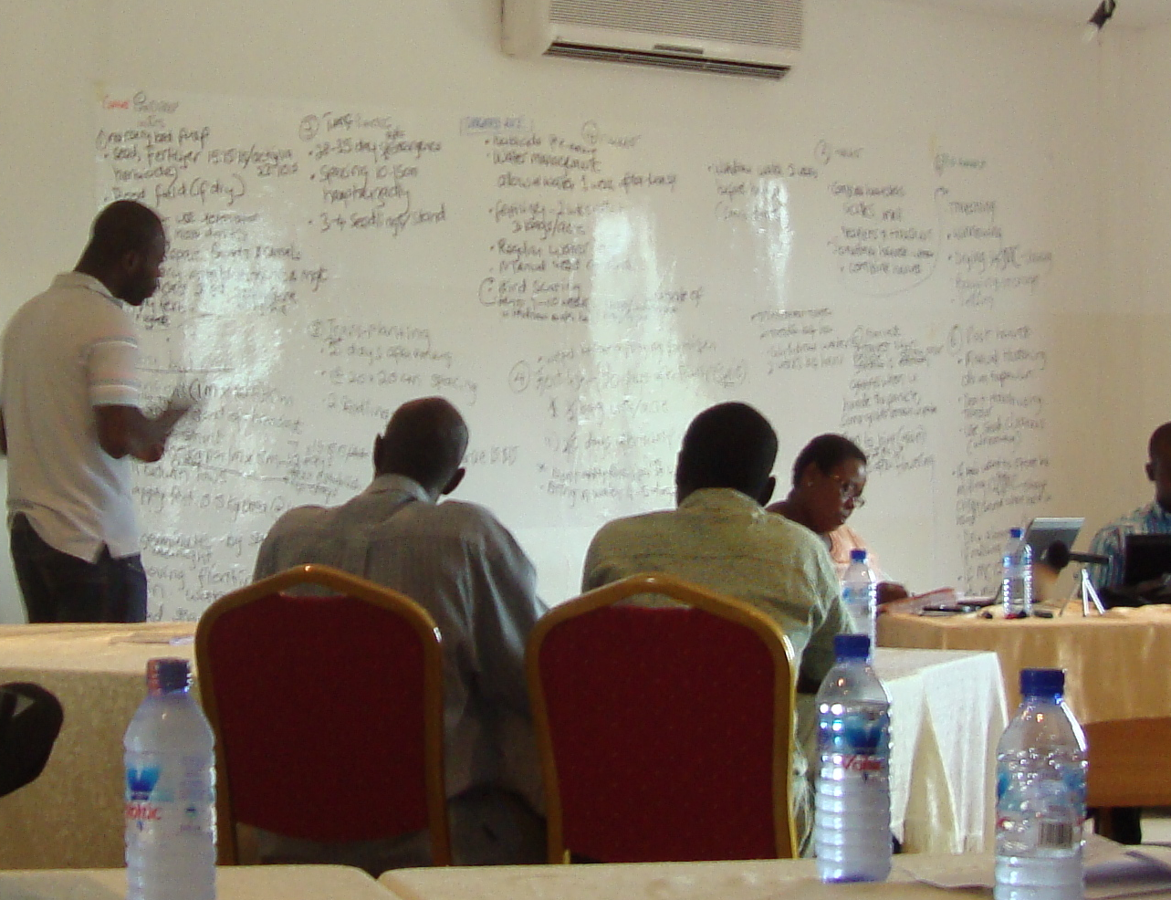

Delegates in Ghana filling in the grid during a write-shop

 | Pre-planting steps | Planting | Care and support of growing crops | Harvest | Post harvest activities by farmers
Typical current approach | Fill in these five sections first – log things as they are said and keep going back to earlier sections to ensure what you have is comprehensive
ISFM technology

This could be done on a flip chart – but having the whole story of the cropping system on the wall will make the drafting tasks easier.

The facilitator should start a conversation with the group following through each of the steps in the farming calendar until the typical current approach is completed.

Tip 4: When thinking about the dates used in this exercise – it is really helpful to have dates coming from the same point. For example: All dates are then added plus or minus days from planting. This approach helps to identify dependent relationships. Many agricultural processes are triggered by the arrival of rains, but from this point it is possible to work out a timetable of events.

Often materials will have dates from different events so talk about days after emergence, days after tillering etc. This can get confusing!

Tip 5: It is helpful to nominate someone from the group to write down the different steps on the sheets on the wall. It is also sensible to type up this information on a laptop as you go along – this means that you can give people copies of the timeline to work with when they are drafting materials.

So an ideal team is:
- Someone to facilitate – it is useful to have someone neutral in this role who can keep asking questions
- Someone to write on the chart
- Someone to transcribe the material on to a Word or Excel table

Accurate recording in language and terms that are farmer friendly is an important step in the process.

The facilitator needs to challenge any lazy descriptions or anything that would not be clear to a farmer (usually too much jargon). Some farmers say they rely on their children to read for them – so they should be kept easy to read and comprehend. It is also essential to keep testing the summaries and ensure that nothing is missed.

Exercise 4: Mapping out ISFM (and other technologies) that will increase productivity and profitability for smallholders

Ideal group size: 3-6 people
Task length: 75 minutes
Materials required: Flip chart paper and pens or cards
Description of the task:

Time line | Pre-planting steps | Planting | Care and support of growing crops | Harvest | Post harvest
Typical current approach | Completed in the previous exercise
ISFM technology | Now it is time to fill in these five boxes

Now it is time to spell out step-by-step the improvements you want to recommend. Once again it is important to set these out in farmer-friendly terms.

It is also important to be sure that any risks and/or economic data is also clearly spelt out in ways that farmers can understand. Smallholders are not able to withstand risk, so only proven technologies should be developed into information for scaling–up.

When benefits of new approaches are being mapped out, it is important to be conservative and based estimates on average farmer trials, not the best possible outcomes from research trials. ASHC also attempts to map out options and not be too prescriptive, but this is challenging in low-literacy environments.

It is useful to note any behaviours and attitudes that may need to be challenged. For example in northern Ghana young people burn stubble to flush out small animals that are hunted for bush meat. This is a cultural practice and it supports food security in the short-term. However, the long-term impact on the soil of stripping out the soil organic mater and killing the micro-organisms in the soil is depleting the soil. This is a cultural practice not a farming practice and so is much harder to challenge.

Exercise 5: What are the benefits to smallholders?
Ideal group size: 3-6 people
Task length: 25 minutes
Materials required: Flip chart paper and pens or cards
Description of the task:
In exercise 4 you spelt out honestly the process for the new technology and set out their likely impact. The next step is to find suitable ways to stress this impact as benefits in a farmer-friendly fashion.

Benefits might include specific improvements to the farmer’s cash income or economic empowerment, food security, or more intangibles such as the farmer’s standing in the community from having a farm admired by other farmers.

You need to think about
- the benefits to the individuals (double your maize yield) rather than national benefits (such as helping the country to be self-sufficient in maize production): national targets rarely motivate people to change their behavior
- how you spell out risks associated with this technology
- the evidence base for the technology you are proposing (and reference this in the materials for extensionists
- producing a simple cost benefit analysis, detailing the additional costs and benefits of the technology and an estimate of the overall quantitative benefit to the farmer. Some projects are reluctant to share this information because they are concerned that they cannot guarantee that research results can be replicated. Without economic information farmers cannot make rational decisions.
- Adding details of a farm and farmer that has successfully implemented the technology.

If you have identified a number of critical behavior changes that are time sensitive, you can think about how you could reinforce the messages about behavior change.

Exercise 6: What constraints might prevent uptake?
Ideal group size: whole group – plenary
Task length: 30 minutes
Materials required: Flip chart paper and pens or cards
Description of the task

Constraints might include the inputs and equipment required (time/labour, quantities of fertilizers, seeds and tools). It is important to also look at the constraints that traditional gender work allocations may place on the uptake of the technology. If women are overburdened at particularly times as a result of the new technology, this might undermine its effectiveness or applicability. So these gender relationships need to be understood and factored into the planning (these should have emerged as and when the technology was field tested).

You may find that you need to deal with issues leading from the constraints. Another significant constraint will be myths, fears and misinformation; for example the fear that fertilizer can ‘poison soil’ is a widely held belief.

Exercise 7: Decide on the best messages for the smallholder farmer
Ideal group size: whole group – plenary
Task length: 25 minutes
Materials required: Flip chart paper and pens or cards
Description of the task:

The next stage in the write-shop process is to agree what information needs to be included in the farmer-friendly communication. This is a judgment call: farmers will want to see enough of the familiar processes from their agricultural year to be confident in the materials and recognize it is relevant to them. But for the sake of simplicity you may not be able to spell every step.

For low literacy farmers each key step needs to be led by a photograph or a graphic. This makes it easier to follow for people with limited literacy to follow what is going on. It also helps to jog the memory even if the text cannot be read or fully understood.

Remember: only use abbreviations for well-known organization names – or crop varieties – never for a process such as biological nitrogen fixation (BNF) – even when they have been explained.

The logic is:
Picture + simple description of the process + simple statement of the benefit

It is useful to try to come up with an overall benefit statement
e.g. 10 ways to double your soybean harvest and improve your soil
Rather than:
Using rhizology to boast soybean production and achieve BNF

Exercise 8: Decide what materials need to be produced
Ideal group size: whole group – plenary
Task length: 15 minutes
Materials required: Flip chart paper and pens or cards
Description of the task:

You need to think about the budget you have the best way of managing the budget to meet your communication needs. This may require some preparation about the costs of a radio series versus a leaflet.

Remember that you need to pull together the whole budget for each media and approach – this may include development time, materials, travel, designers, editors, presenters, seed, printing … depending on the choice of media and approaches you decide are appropriate.

Exercise 9: Drafting materials
Ideal group size: 5-7 people
Task length: 120 minutes
Materials required: Flip chart paper and pens or cards and access to computers
Description of the task:
This may seem to be a long time into the process to start to generate materials – but you have the toolkit to be able to quickly develop materials in a variety of media, or across a wide partnership, confident that the messages will be consistent.

ASHC is building up a set of guidance notes for each media and approach. These can be downloaded from the Toolkit.

Tip 6: Make one of the group responsible for ensuring the materials are in farmer-friendly language.

Facilitation plan

Exercise | Duration | Brief description of activity | Aim
1 | 30 minutes | Exercise: Ask the groups to think about the term farmer-friendly. Ask them to consider what this means in terms of producing materials. | To create a set off language rules for the subsequent exercises today
1.1 | 5-7 minutes per group | Structured feedback from groups on exercise 1 – ask groups to only report back on areas that are new – or areas where there group has deviated from anything that had already been reported | Produce a consolidated list of rules and prompts to be on the wall for the duration of the write-shop
1.2 | 5 minutes | Facilitator runs through the rules – now consolidated into one list – get agreement from the group to the rules and prompts they have created | Get a consensus to move forward
2 | 20 minutes | Exercise: Poster session  Think about the links between media and gender | Get the group thinking about how gender and media and approaches are related
2.1 | 15 minutes | Structured feedback to provide a checklist of which media and/or approaches are good for which media | Create some options for assessment latter in the day.
3 | 75 minutes | Exercise: Mapping current farmer practice | To clarify step by step what farmer are doing.
4 | 75 minutes | Exercise: Mapping proposed improved farmer practice | To clarify step by step what farmer will be expected to do
5 | 25 minutes | Exercise: Map out the benefits | Look at how benefits can be turned into messages
6 | 20 minutes | Exercise: Map out the constraints | Look at how planning for material development may also have to align to supply chain or value chain development work

Facilitation plan continued…

Exercise | Duration | Brief description of activity | Aim
7 | 25 minutes | Decide on the best messages for the smallholder farmer | Get agreement on how the benefits of the technology are to be shared with the farmers.
8 | 25 minutes | Decide which materials to produce | Get agreement on the media that best meet the needs of the farmers – and make best use of the prevailing opportunities to partner with media producers
9 | 120 minutes | Drafting the content for the materials | Start to map out what the materials should look like.

