**Burkina Faso Sahel**

**FERTILIZER USE OPTIMIZER 2:paper**

**version** 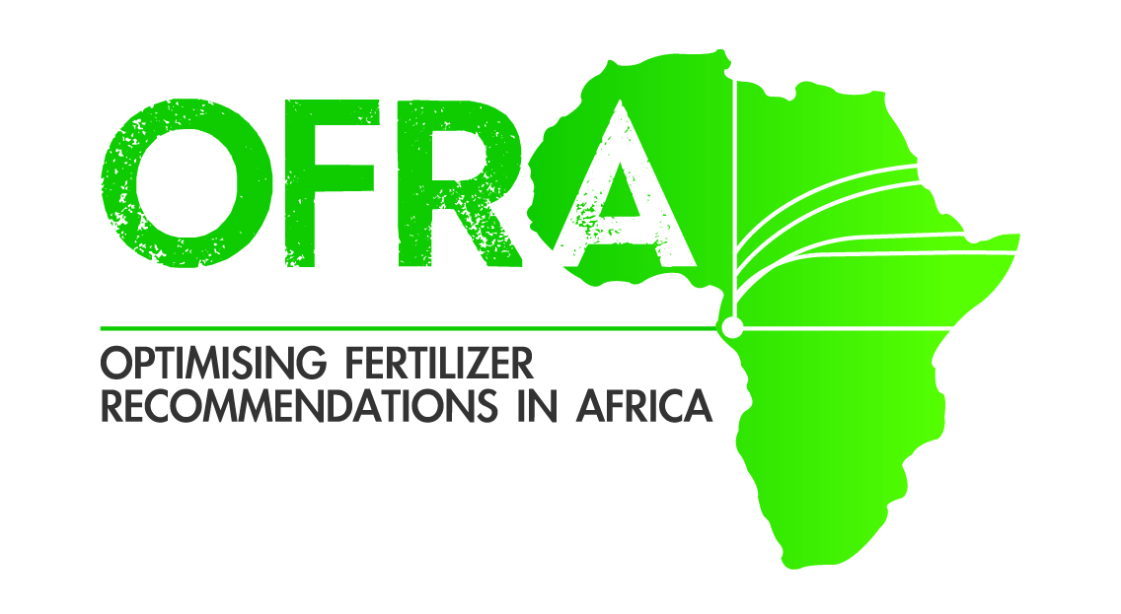



**The below assumes:**

* Measurement is with a Lafti water bottle lip that holds 7.5 ml and about 5.25 g urea and 8.25 g DAP, TSP or KCl, or with a Gino tomato cup of 70 ml bottle to hold 50 g urea and 77 DAP, TSP or KCl.
* It is assumed maize and sorghum are planted with 80x40 cm spacing and the legumes (cowpea, and groundnuts) are planted with 40 X 40 cm spacing.
* Fertilizer costs per 50 kg bags are: 25,000 for urea and KCl, and 26,000 each for TSP.
* Commodity values per kg are: 126 for maize; 141 for sorghum; 118 for rice; 310 for groundnut and 290 for cowpea

**Broadcast width: 4 m; WAP =** Week After Planting

**Level 3 financial ability (maximizes profit per A).**

* Sorghum. Apply 23 kg/ha TSP at planting time (point apply with 1 water bottle cap for 5.2 m)
* Lowland rice. Apply 43 kg/ha urea at tillering time (broadcast 1 gino tomato can 70 mL 3 m wide x 3.6 m long.)
* Pearl millet. Point apply 26 kg/ha TSP at 2 WAP (point apply with 1 water bottle cap for 4.6 m). Sidedress 50 kg/ha urea (point apply with 1 water bottle cap 1.5 m) at 6 WAP