 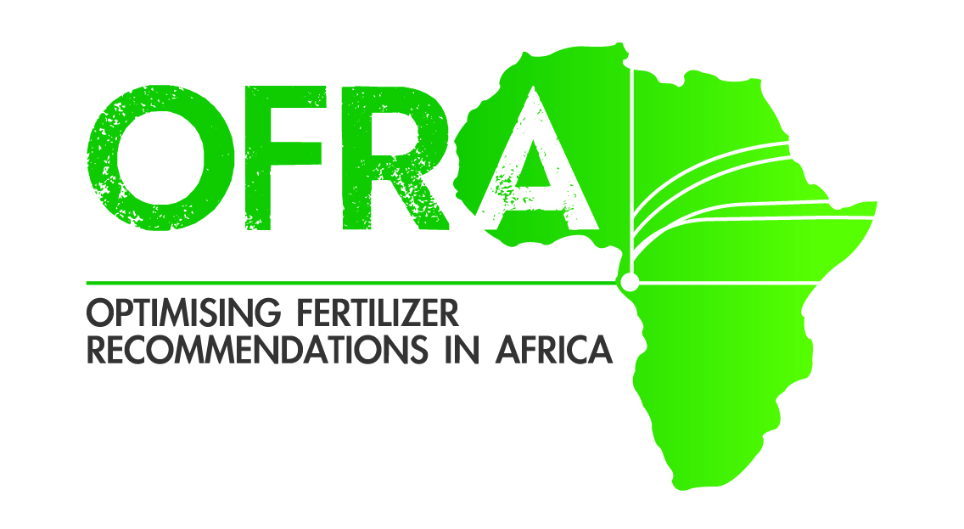

**Burkina Faso North Sudan Savanna**

**FERTILIZER USE OPTIMIZER 1 paper**

**The below assumes:**

* Measurement is with a Lafti water bottle lip that holds 7.5 ml and about 5.25 g urea and 8.25 g DAP, TSP or KCl, or with a Gino tomato cup of 70 ml bottle to hold 50 g urea and 77 DAP, TSP or KCl.
* It is assumed: maize and sorghum are planted with 80 cm row spacing band application; soybean, cowpea, and groundnut 40 cm; and rice 20 cm.
* It is assumed grain prices per kg: 126 maize; 142 sorghum; 119 rice, Groundnut 310, Cowpea 290, Soybean 143.
* It is assumed 50 kg of fertilize: 25000 CFAurea and KCl; 26000 CFA TSP and 42000 CFA.
* **Broadcast width: 4 m; WAP =** Week After Planting

**Level 1 financial ability.**

* For Rice, lowland, broadcast 44kg/ha urea (water bottle lid for 2.9 m) at 6 WAP.
* For Maize band apply 49 kg/ha urea (water bottle lid for 0.8 m) at 6 WAP
* For sorghum, band apply 28 kg/ha of urea (water bottle lid for 1.1 m) at 6 WAP.

**Level 2 financial ability.**

* For Rice, lowland, broadcast 40 kg/ha urea (water bottle lid for 3.1 m) at 2 WAP and 68 kg/ha at panicle initiation (water bottle lid for 1.9 m).
* For Maize band apply urea 40 kg/ha (water bottle lid for 0.8 m) at 2 WAP and 50 kg/ha (water bottle lid for 6.5 m) at 6 WAP
* For sorghum, band apply 39 kg/ha of urea (water bottle lid for 0.8 m) at 6 WAP.

For Soybean band apply 26 kg/ha of DAP (water bottle lid for 3 m**)**

**Level 3 financial ability (maximizes profit per ha)**

* For Rice, lowland, broadcast 40 kg/ha urea (water bottle lid for 3.1 m) at 2 WAP and 68 kg/ha at panicle initiation (water bottle lid for 3.9 m).
* For Maize band apply 41 kg/ha of DAP (water bottle lid for 1.3 m) at 2 WAP and 107 kg/ha of urea (water bottle lid for 0.3 m) at 6 WAP
* For sorghum, band apply 48 kg/ha of urea (water bottle lid for 0.6 m) at 2 WAP.
* For Groundnut band apply 27 kg/ha of DAP (water bottle lid for 2 m) and 7 kg/ha TSP (water bottle lid for 7.5 m) at 2 WAP
* For Soybean band apply 41 kg/ha of DAP (water bottle lid for 1.3 m) and 21 kg/ha TSP (water bottle lid for 2.5 m) at 2 WAP